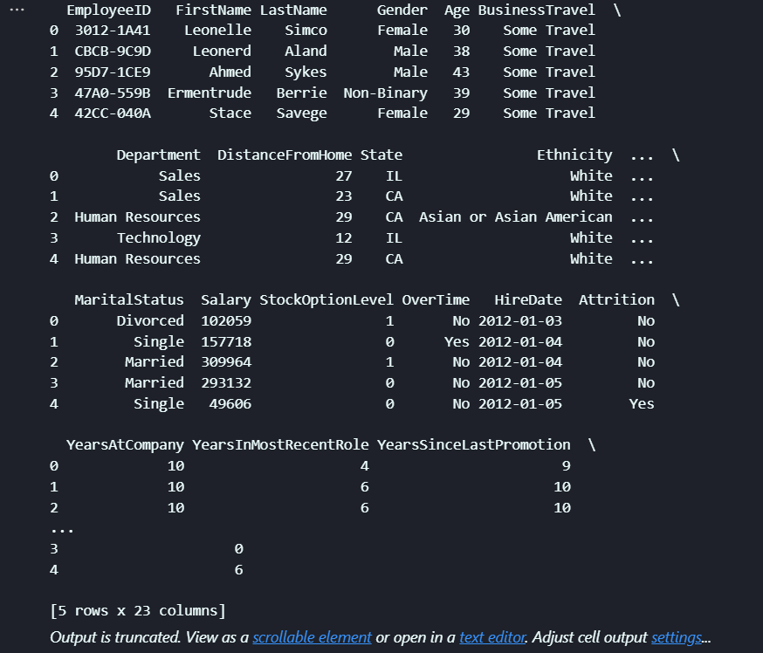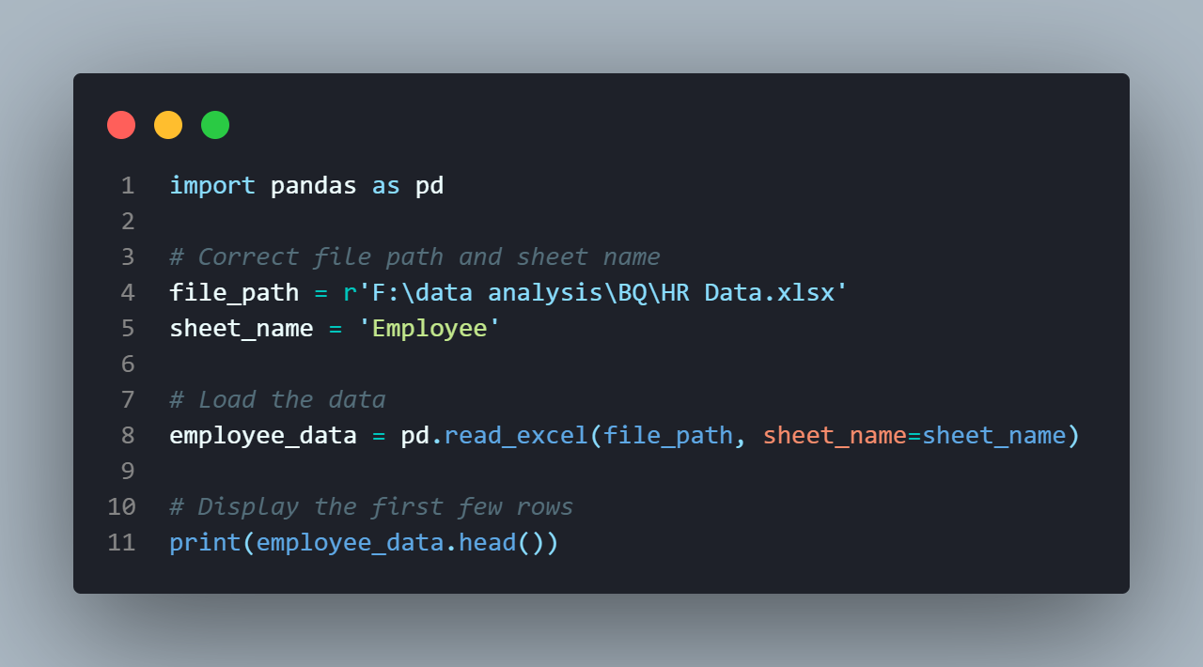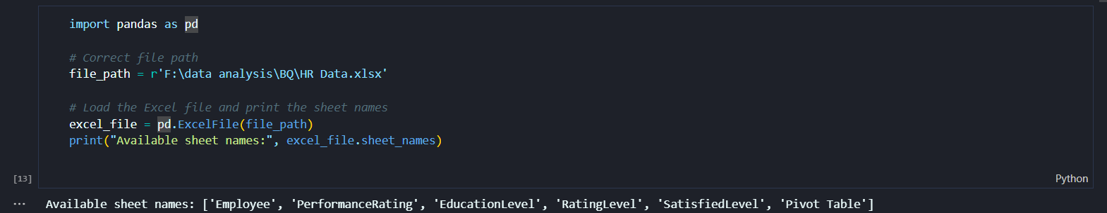

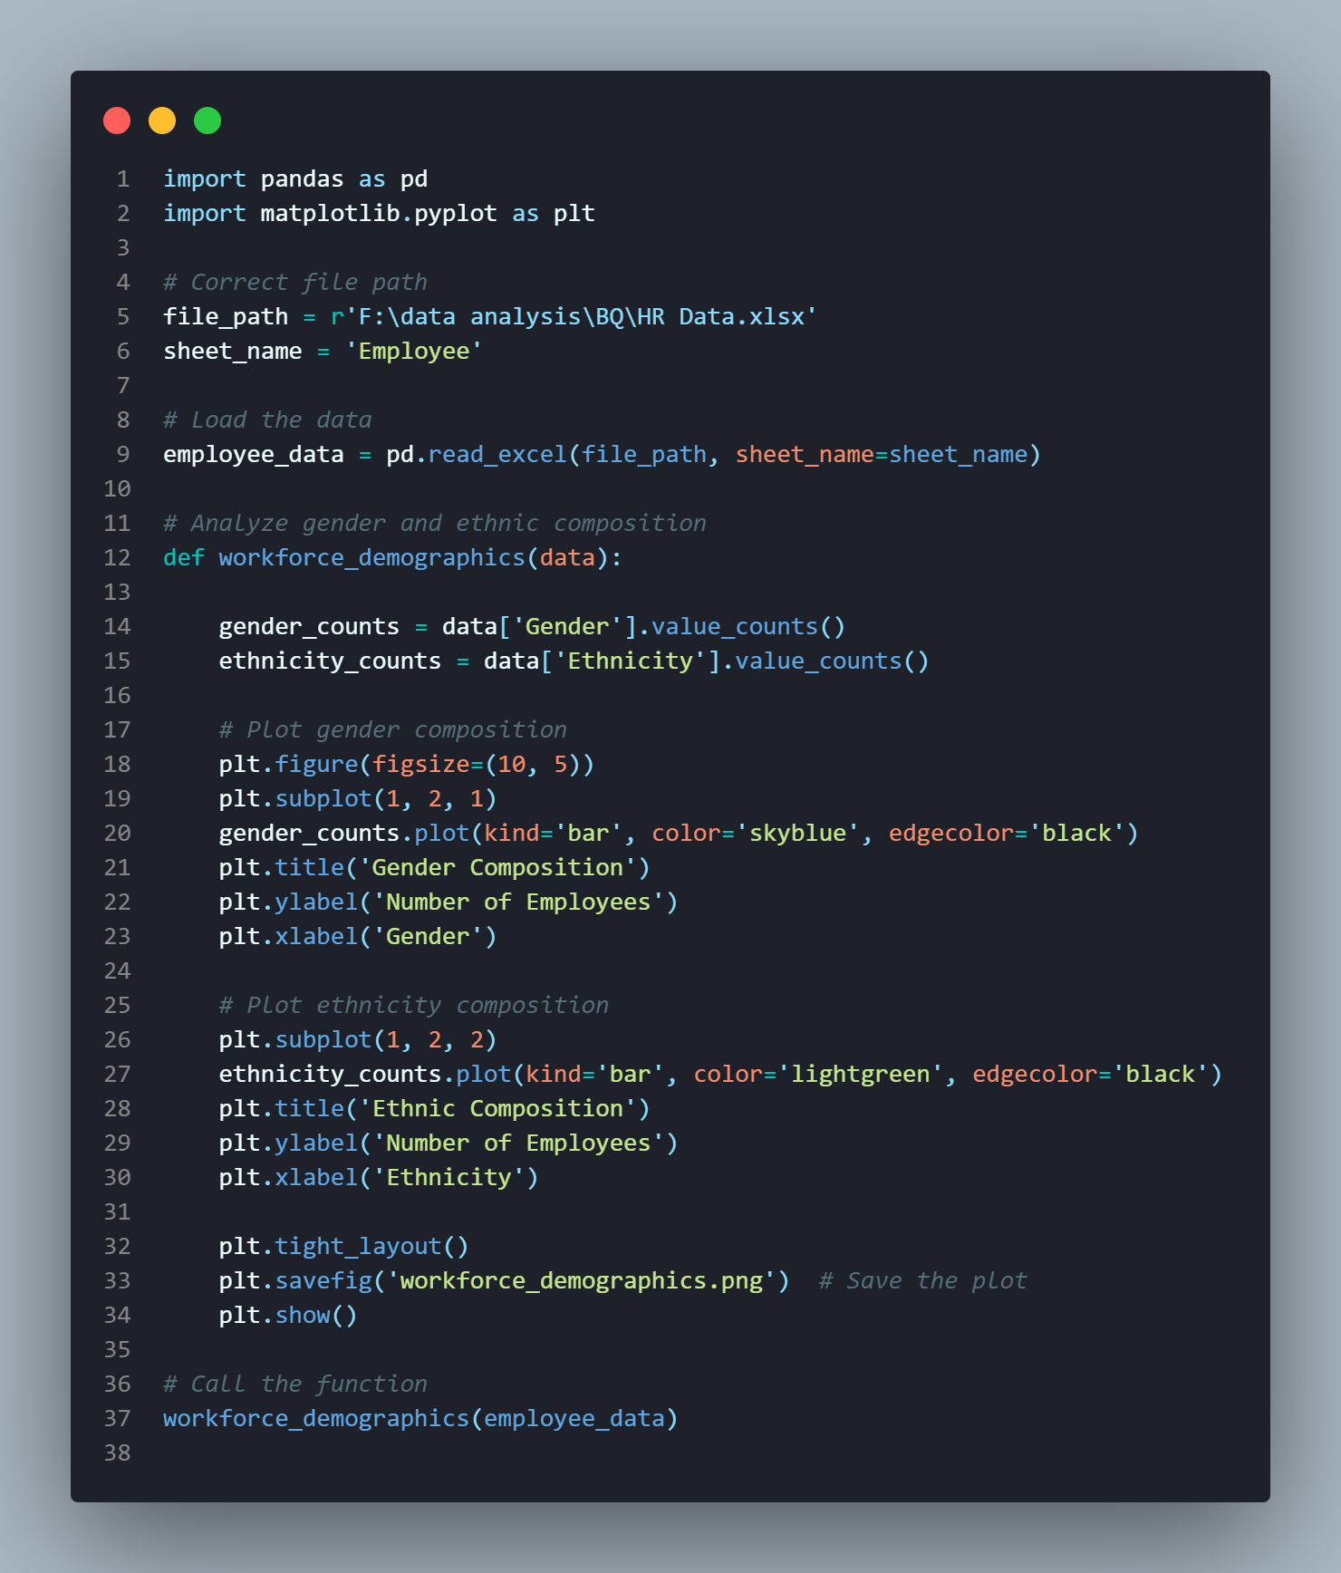***1. What is the gender and ethnic composition of the workforce?***

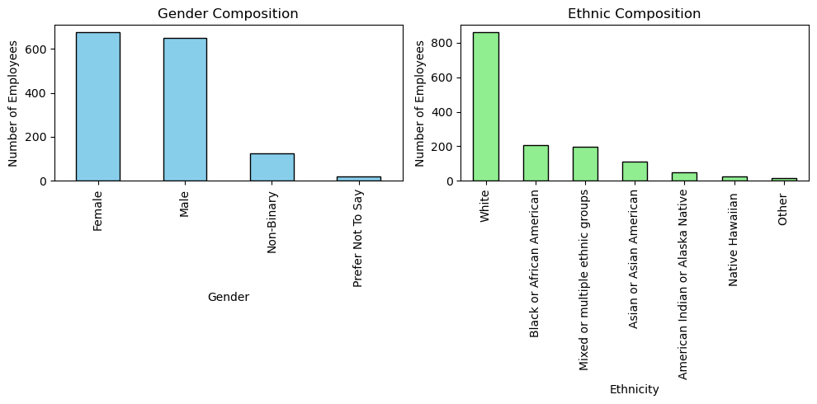

______________________________________________

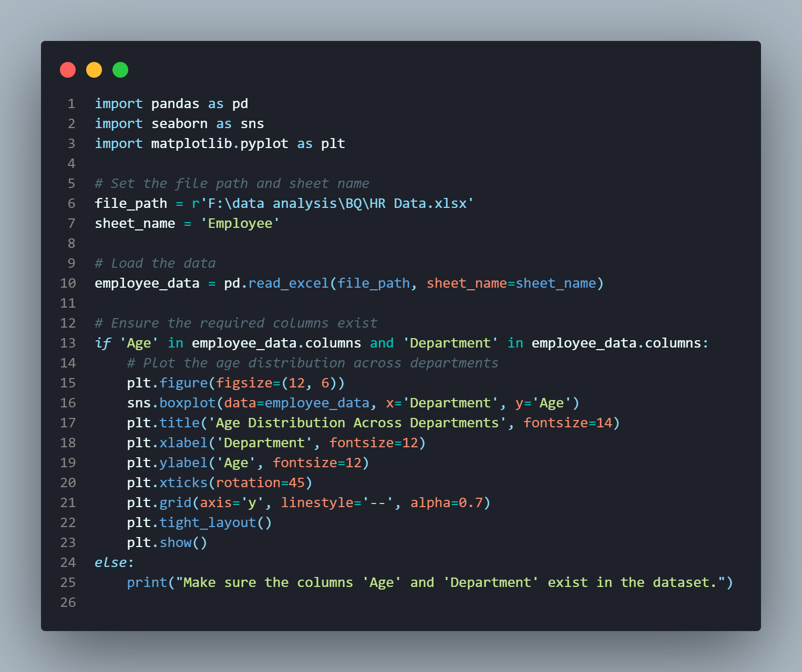*2 .How does age distribution vary across departments ?*

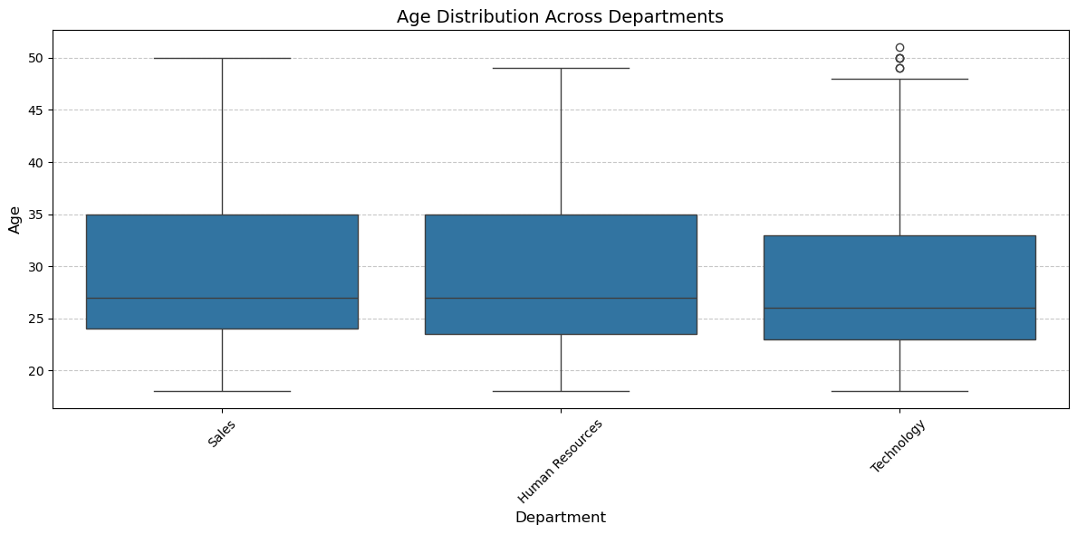

______________________________________________

*3. What are the key factors driving employee attrition?*

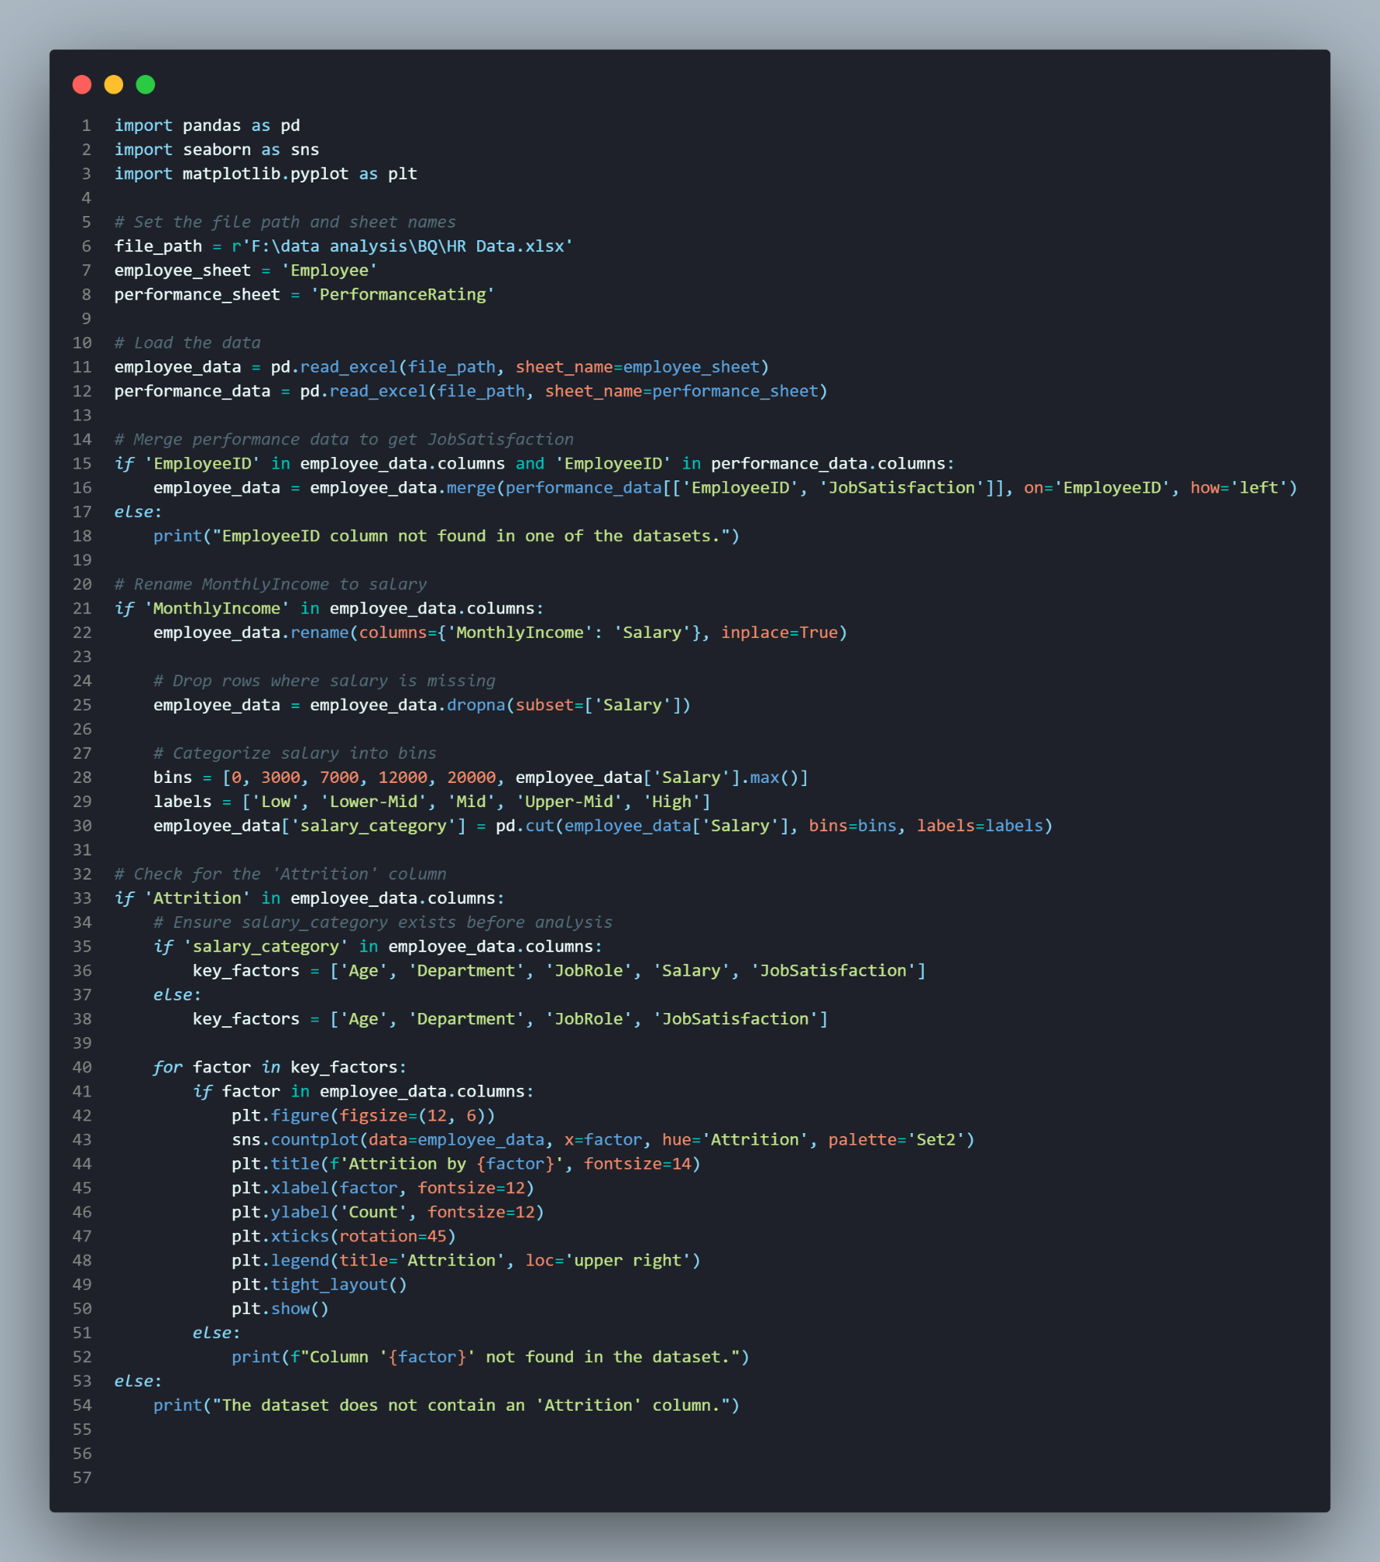 *4 .How does attrition vary across demographics (e.g., gender, ethnicity) and departments ?*

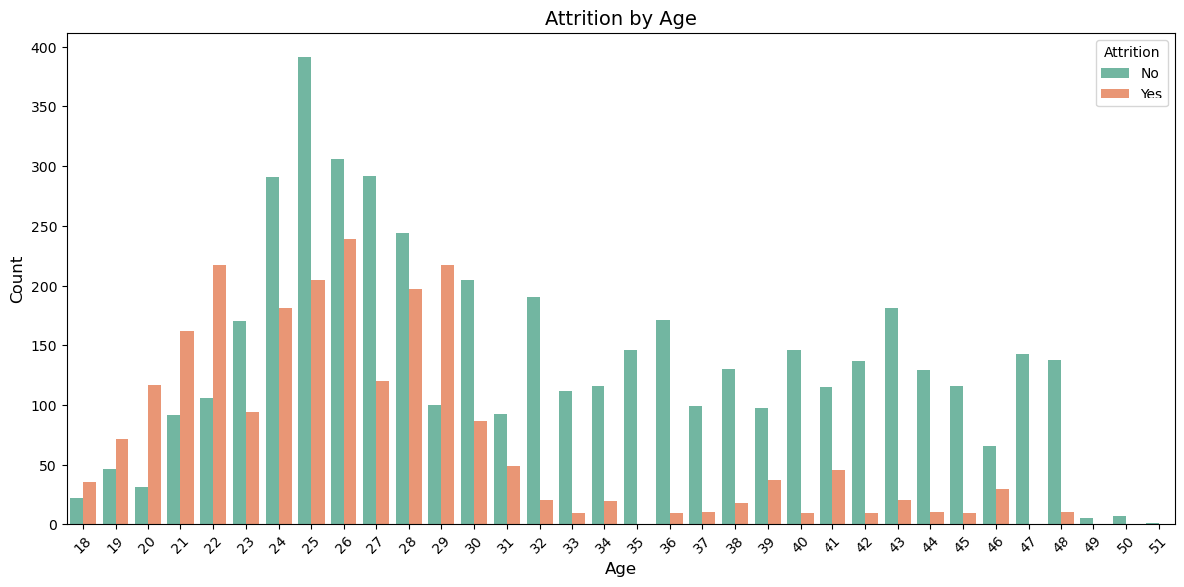

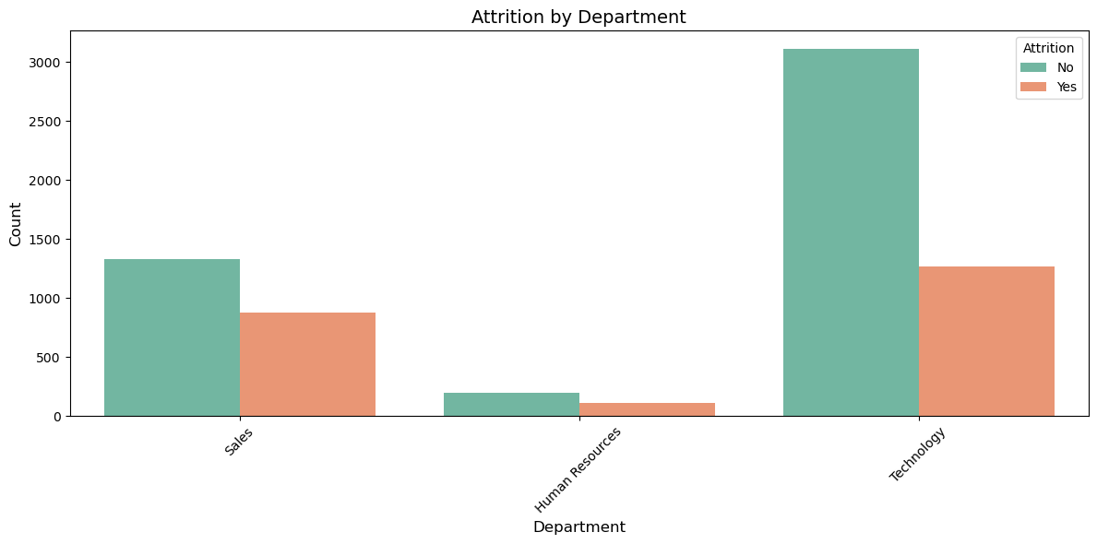

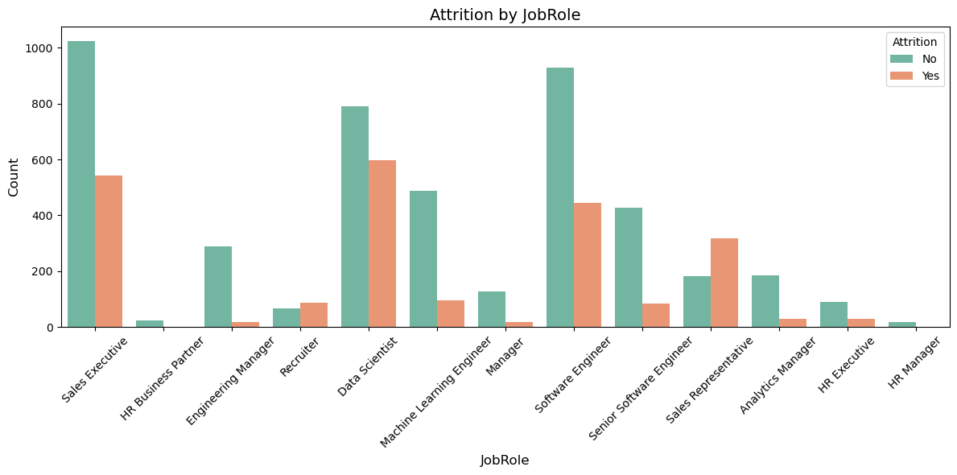

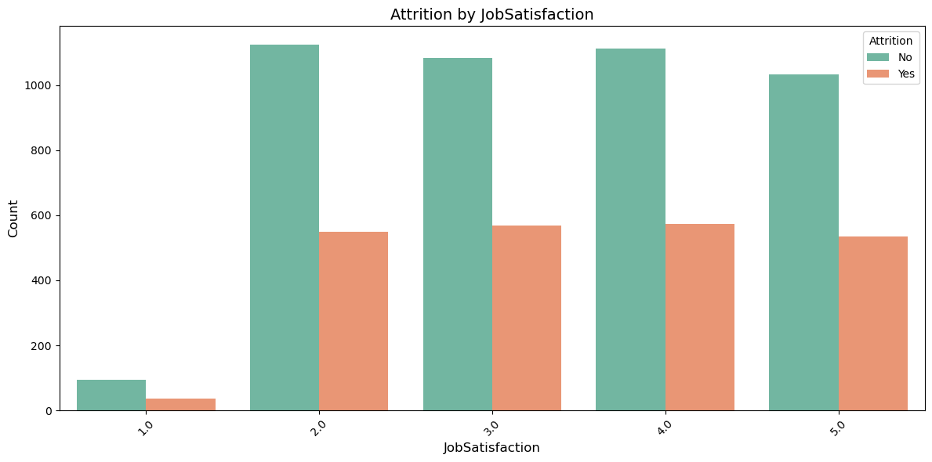

*6 .Is there a significant deference in salaries across departments, genders, or other demographic groups ?*

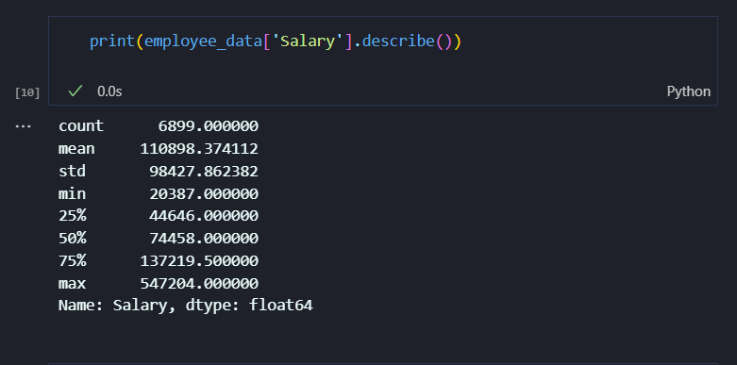

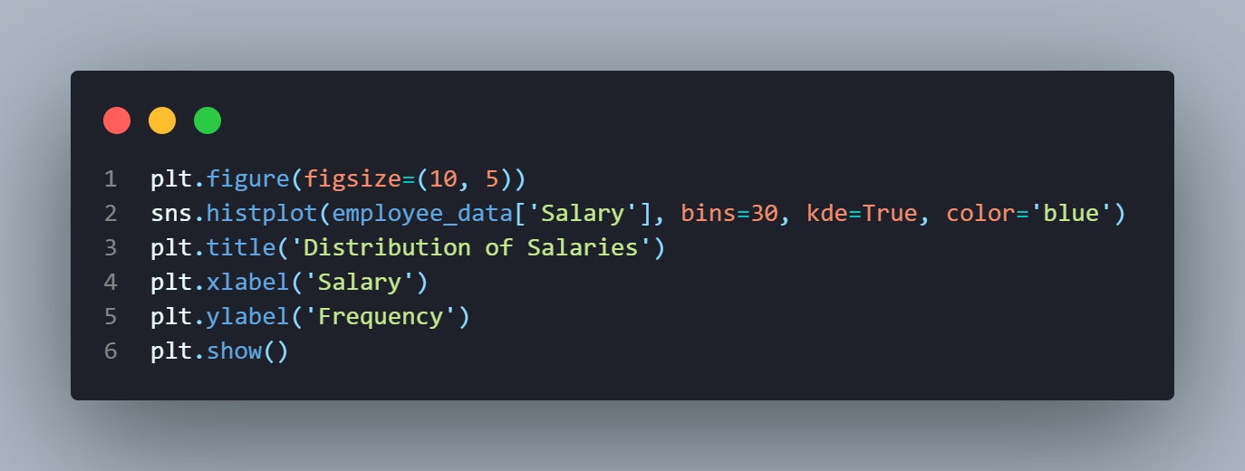

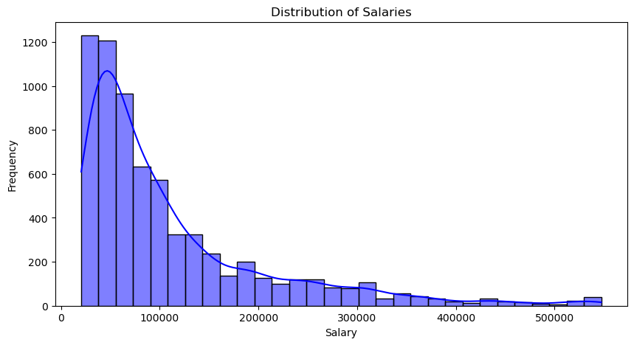

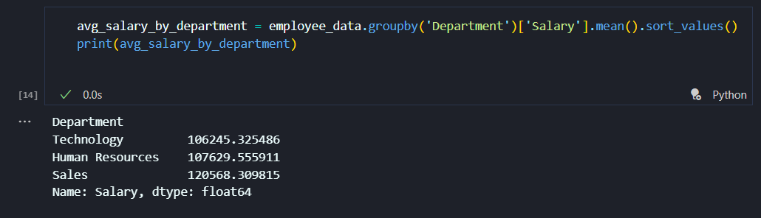

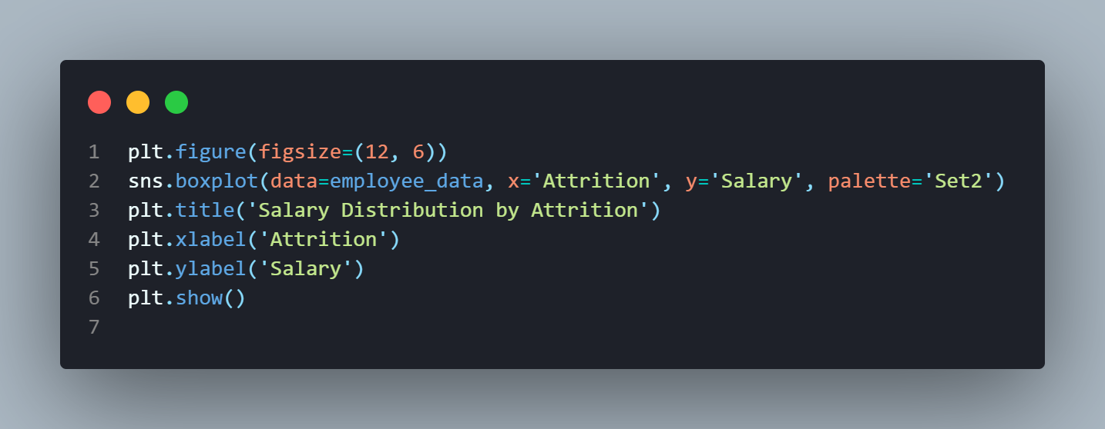

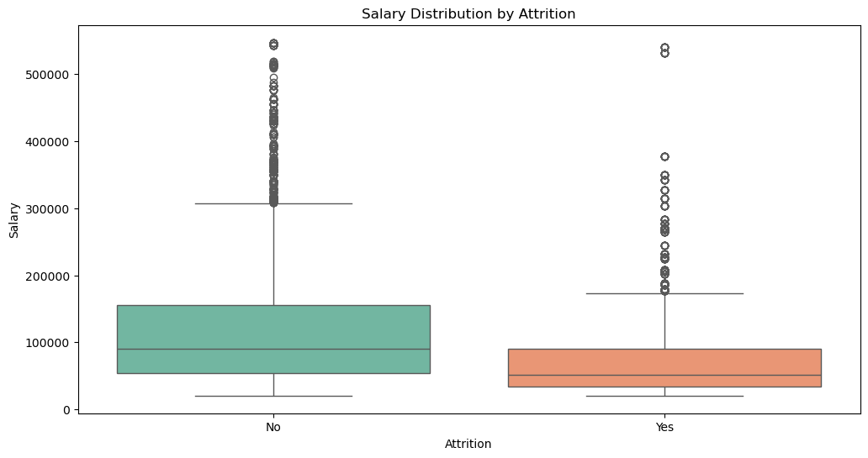

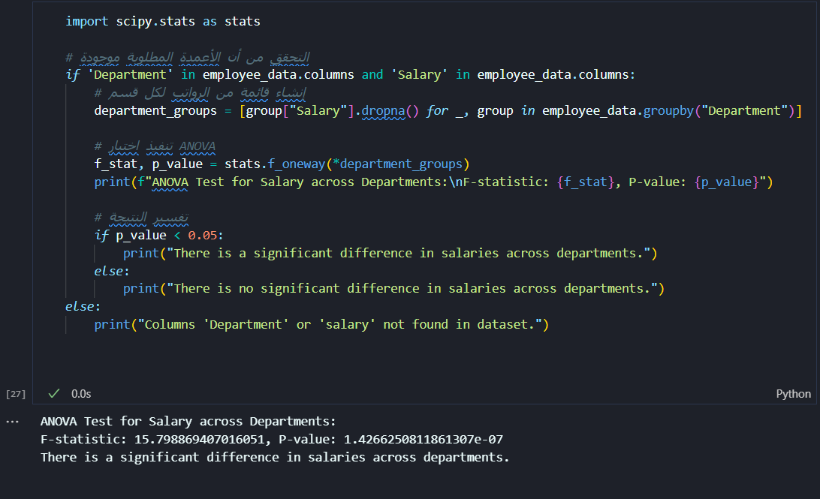

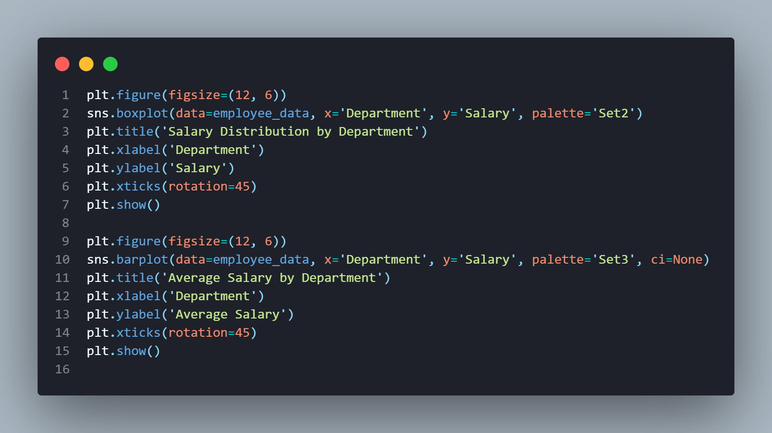

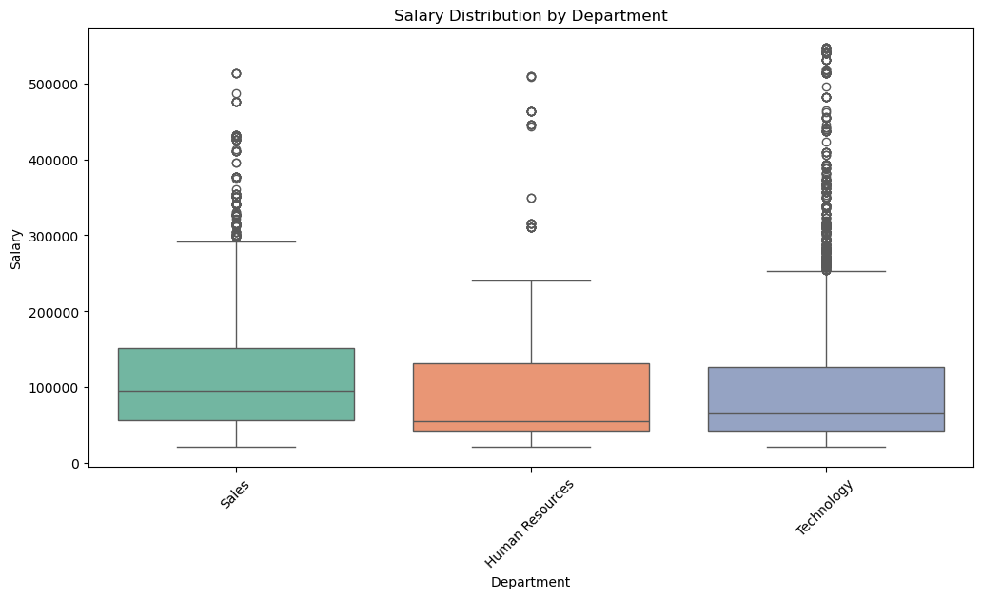

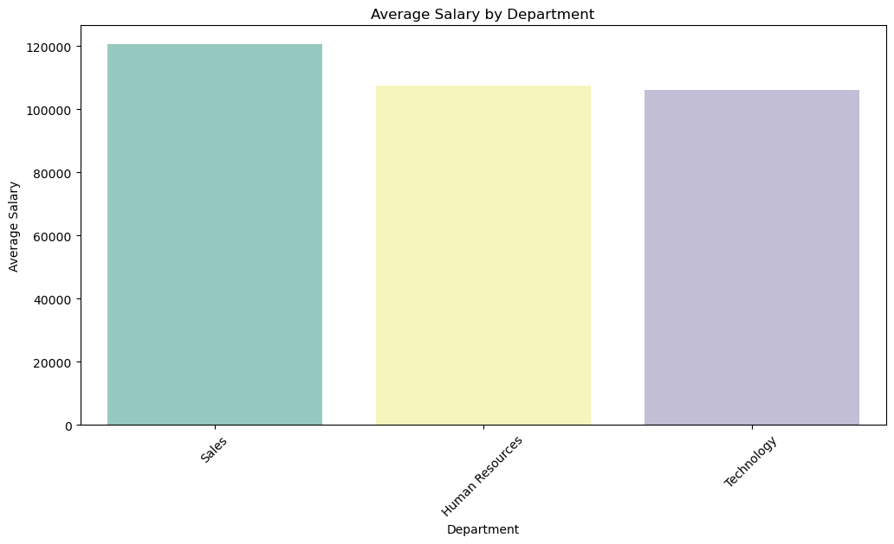

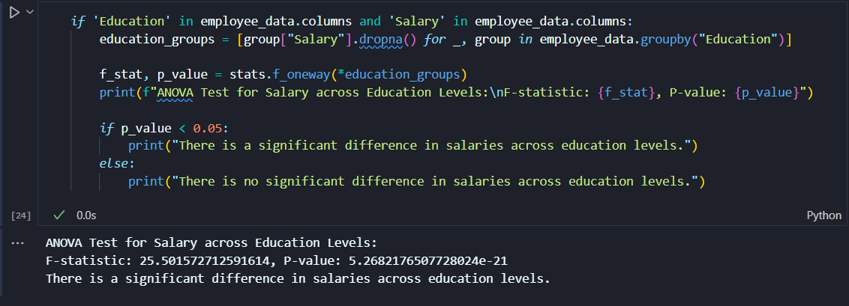

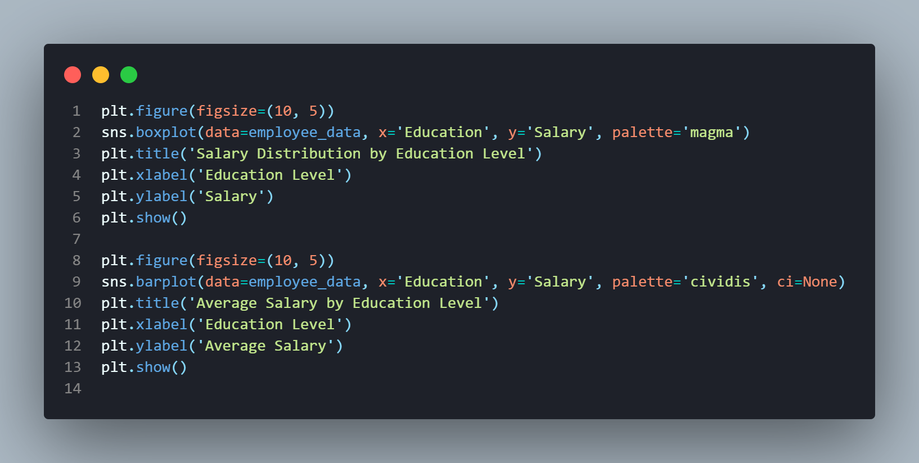

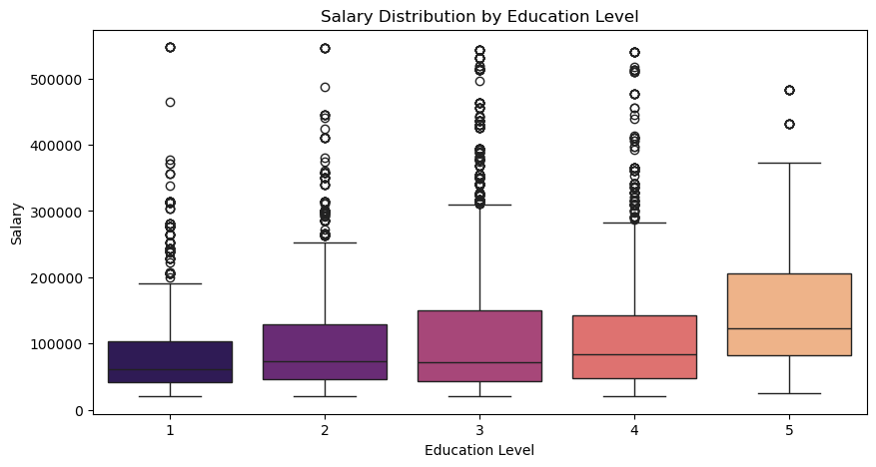

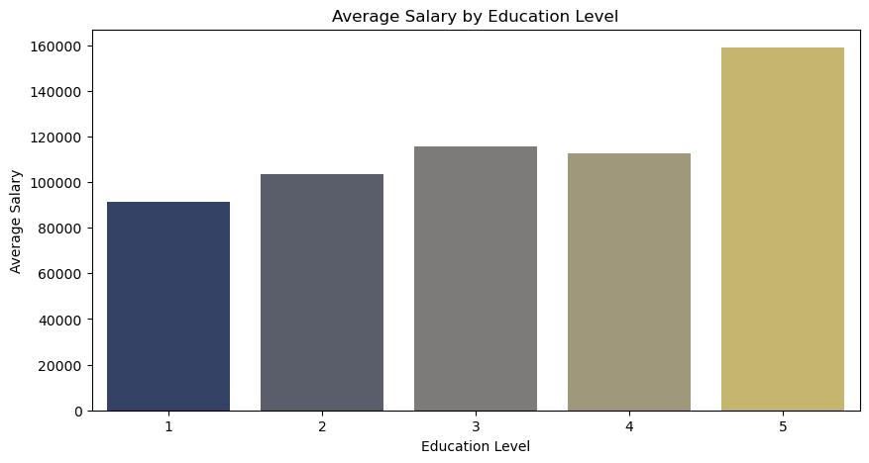

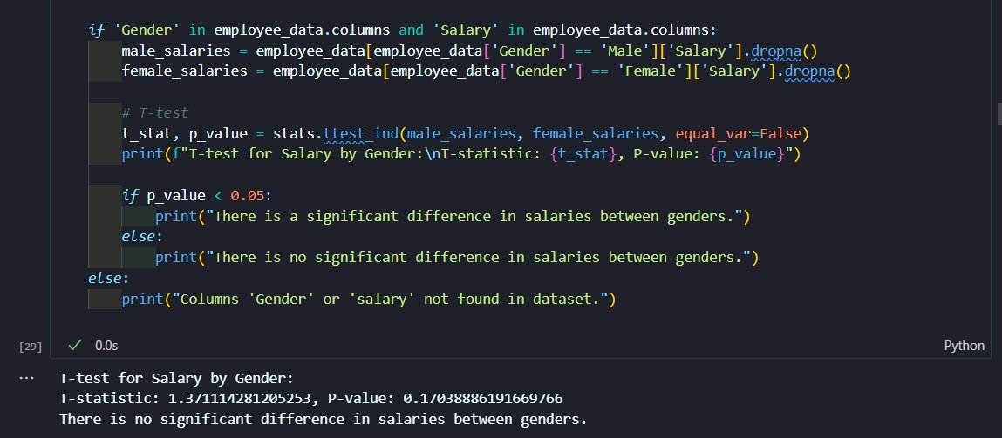

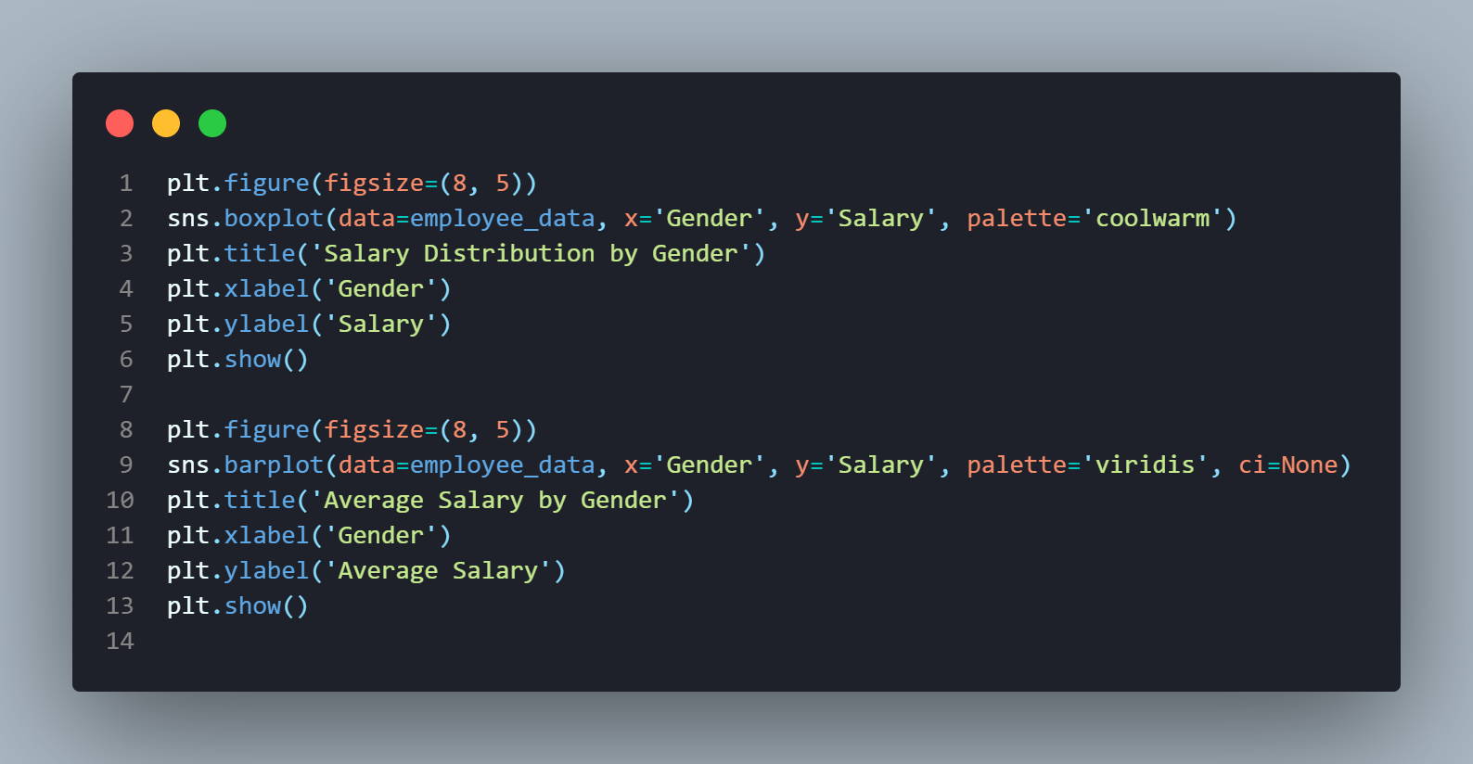

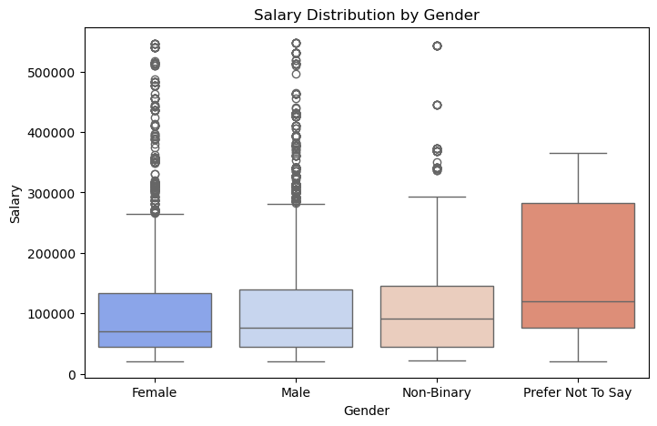

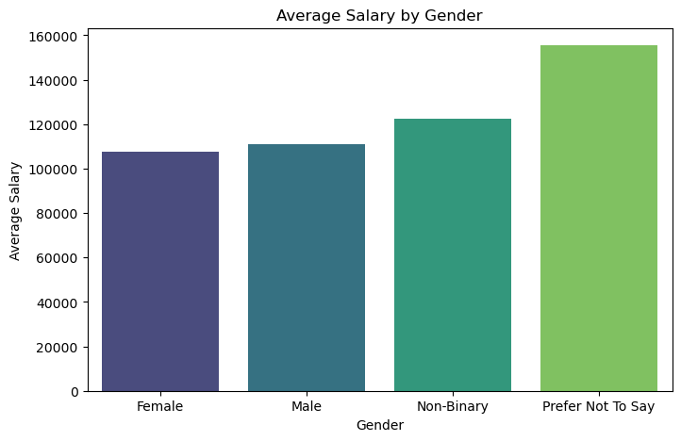

________________________________________________________

*4 . How does attrition vary across demographics (e.g., gender, ethnicity) and departments?*

*7 . How does marital status influence attrition rates?*

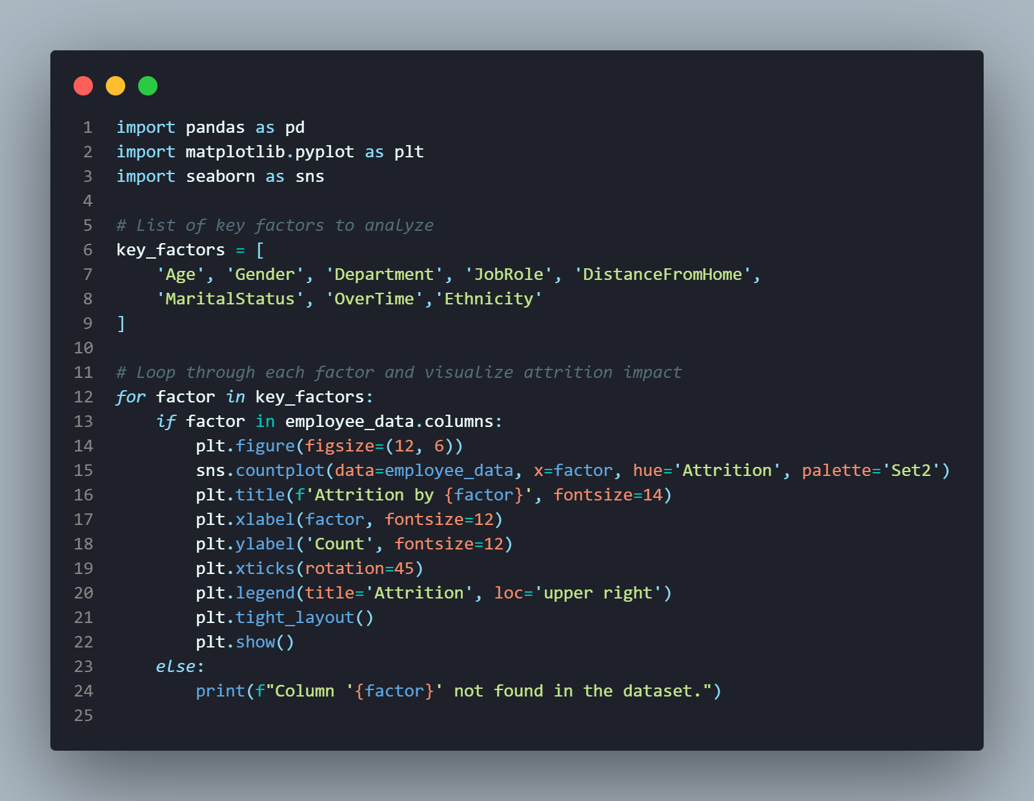



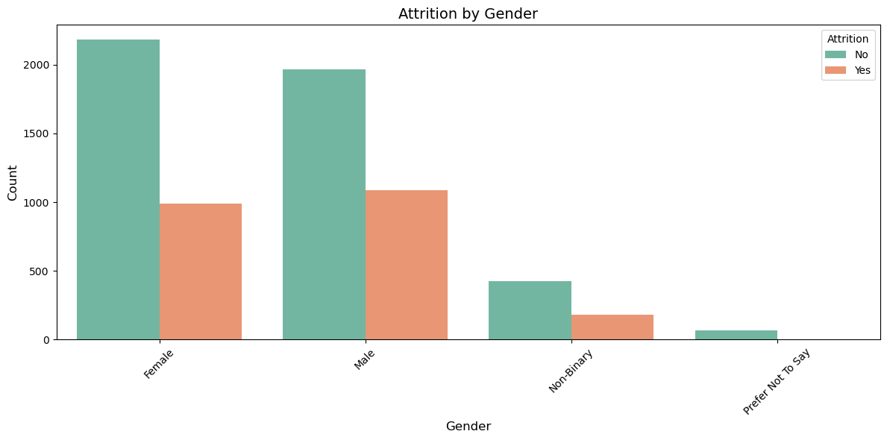





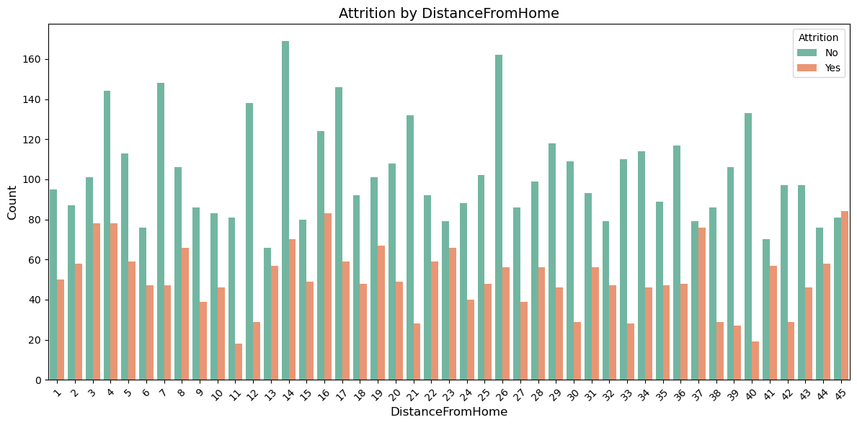

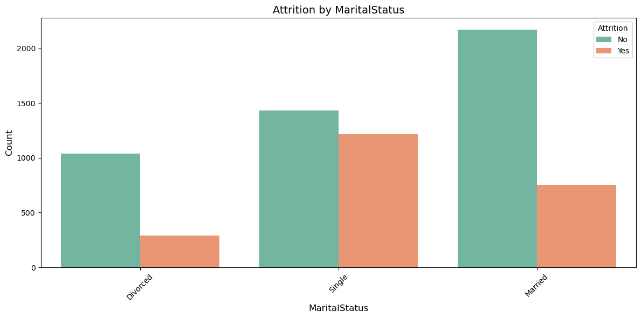

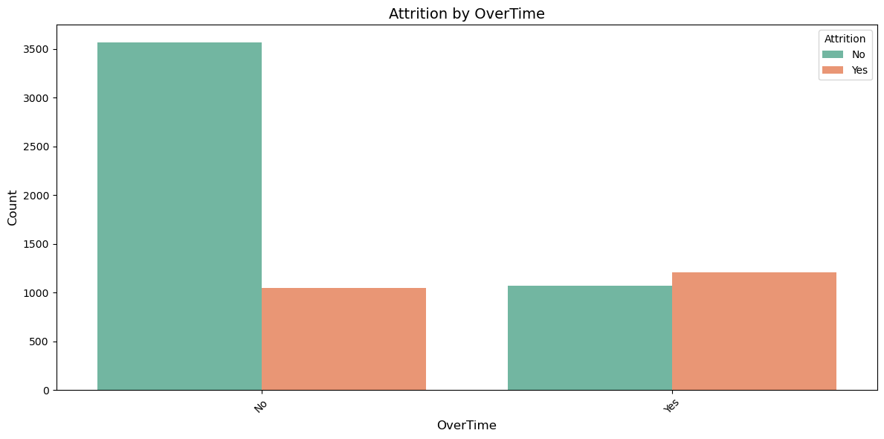

*5 . Is there a correlation between DistanceFromHome and attrition?*

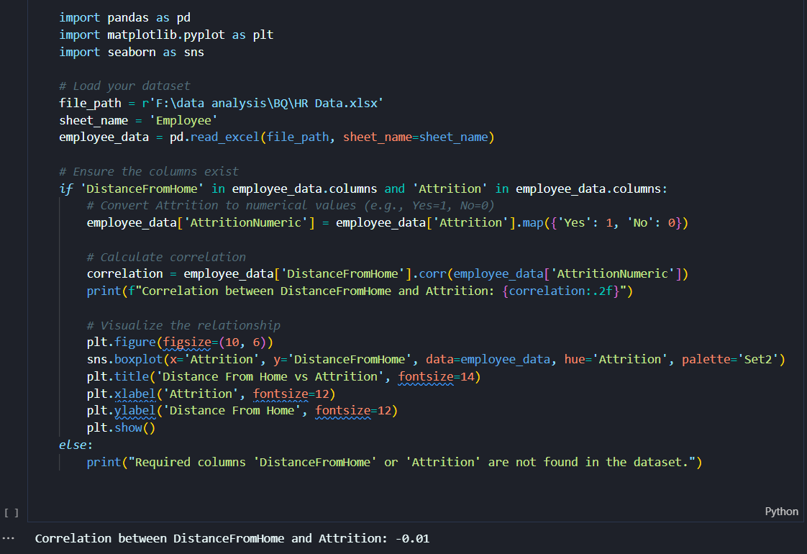

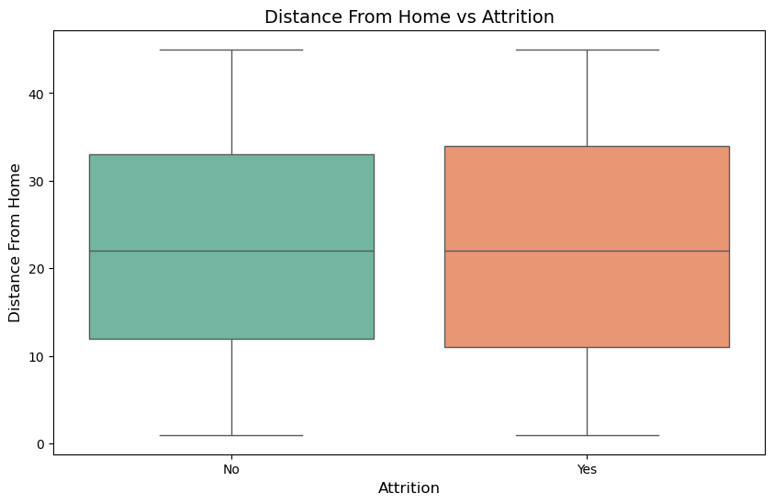

________________________________________________________

*6 .Is there a significant deference in salaries across departments, genders, or other demographic groups ?*

*7. How does stock option level influence employee retention and satisfaction?*

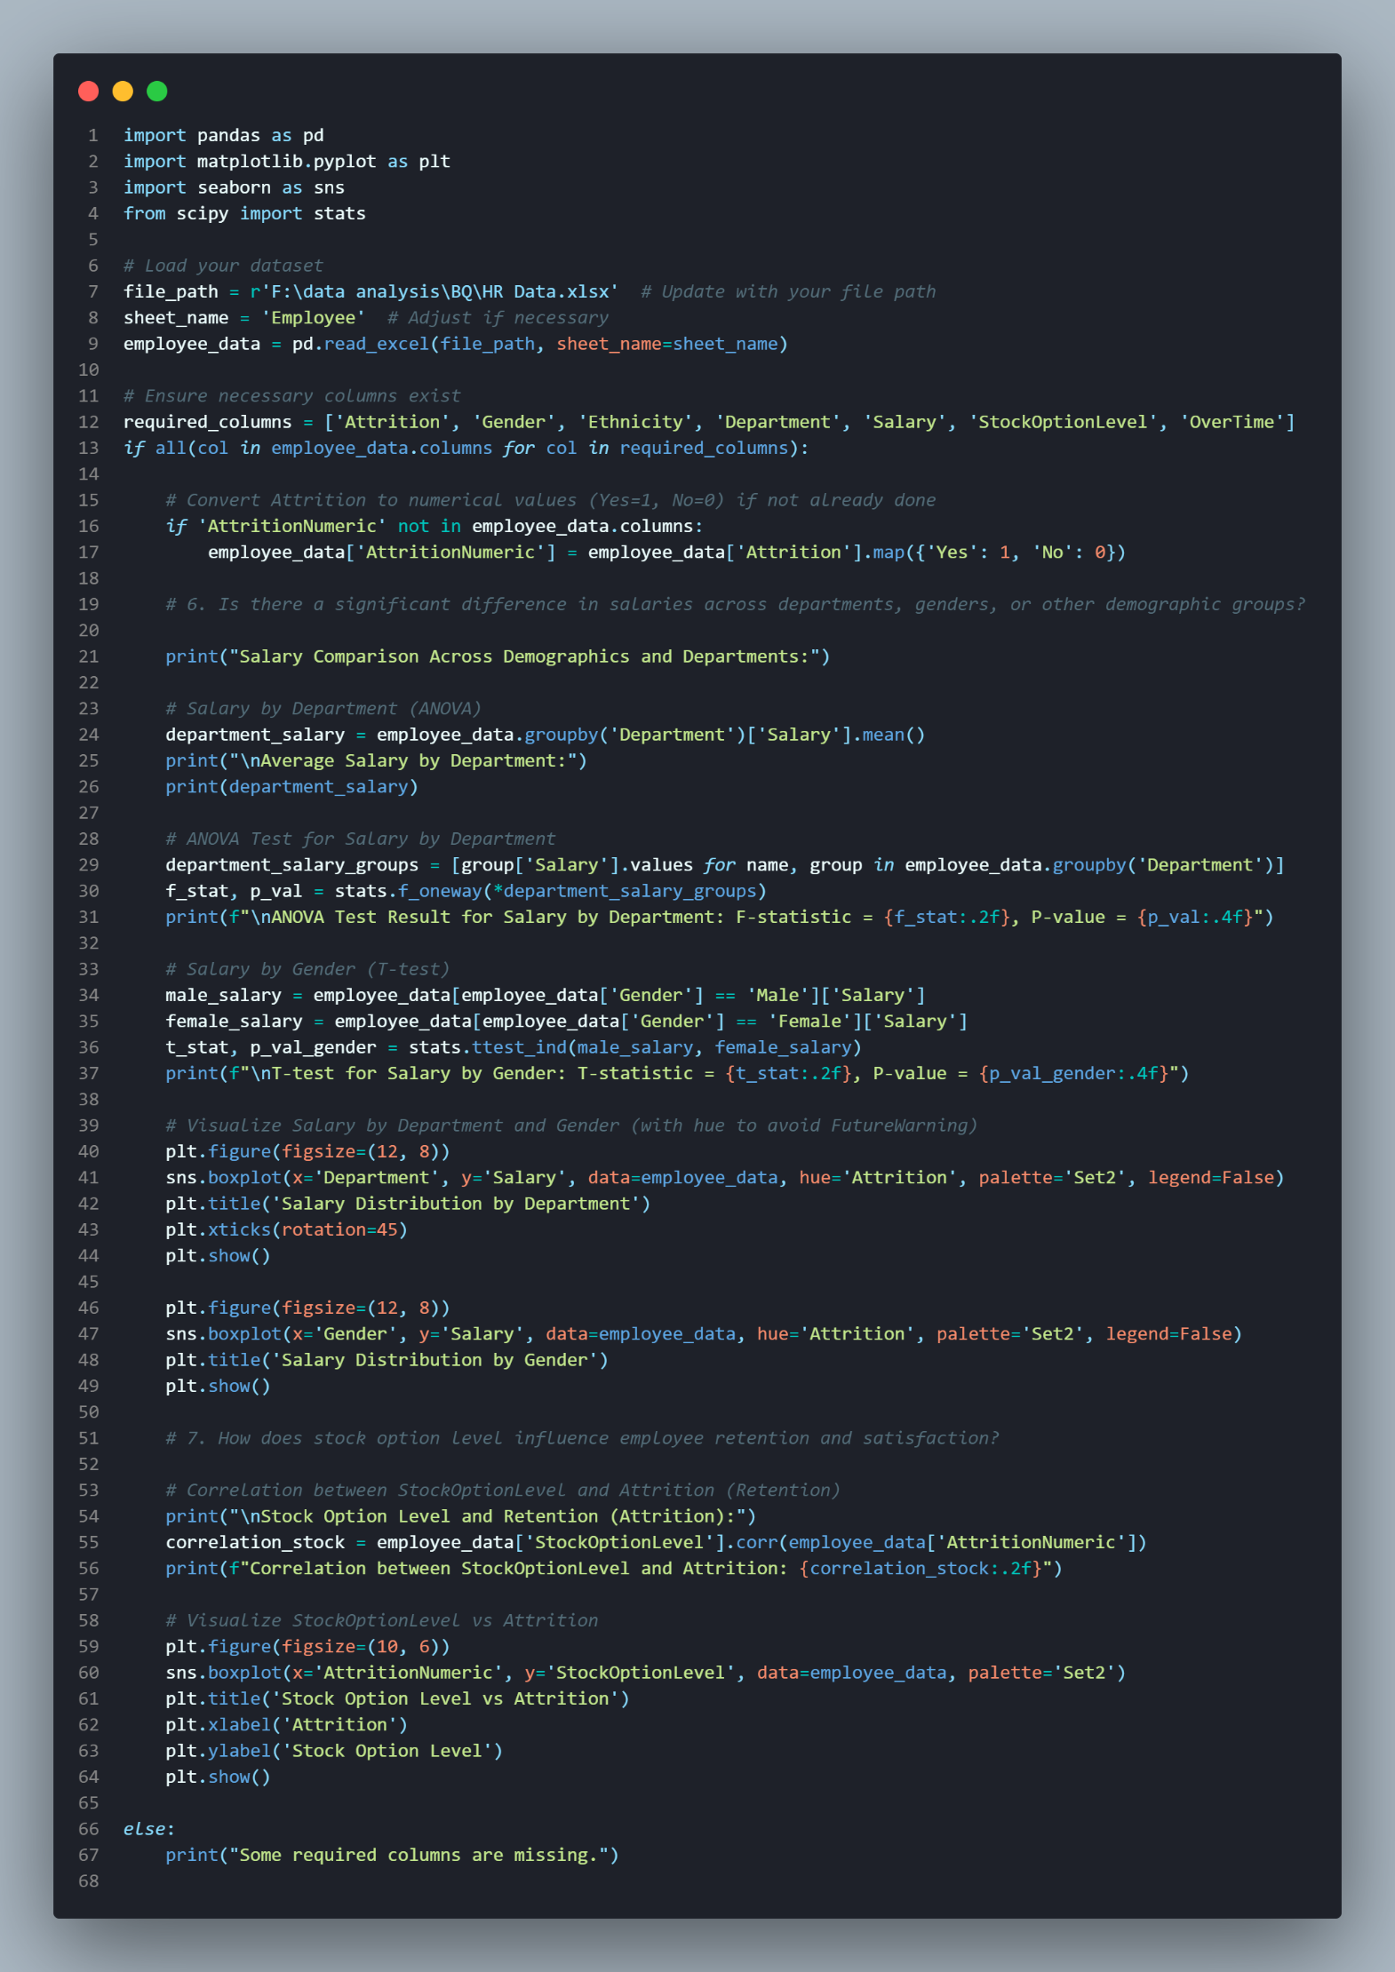

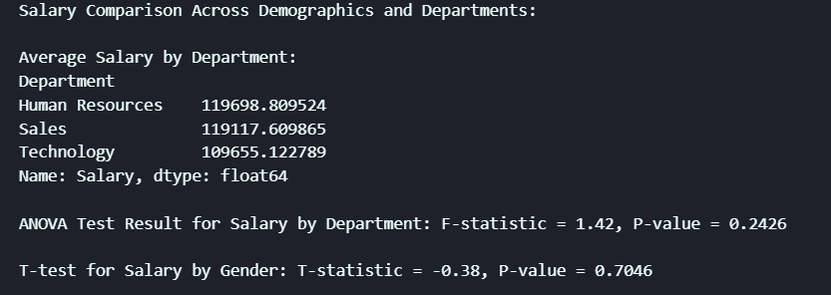

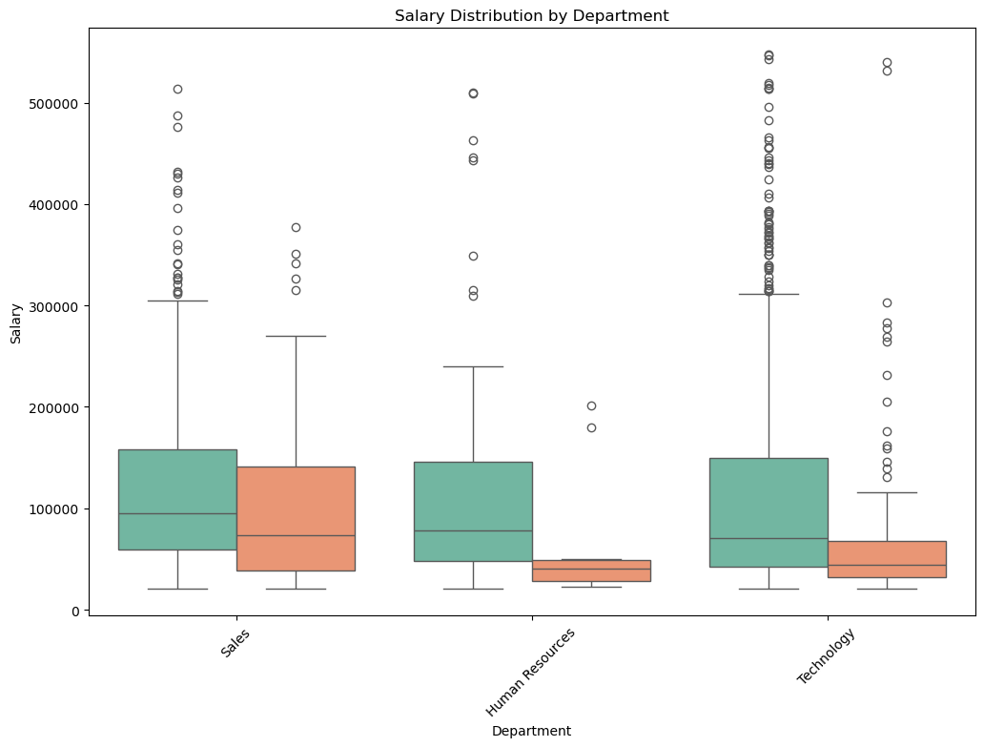

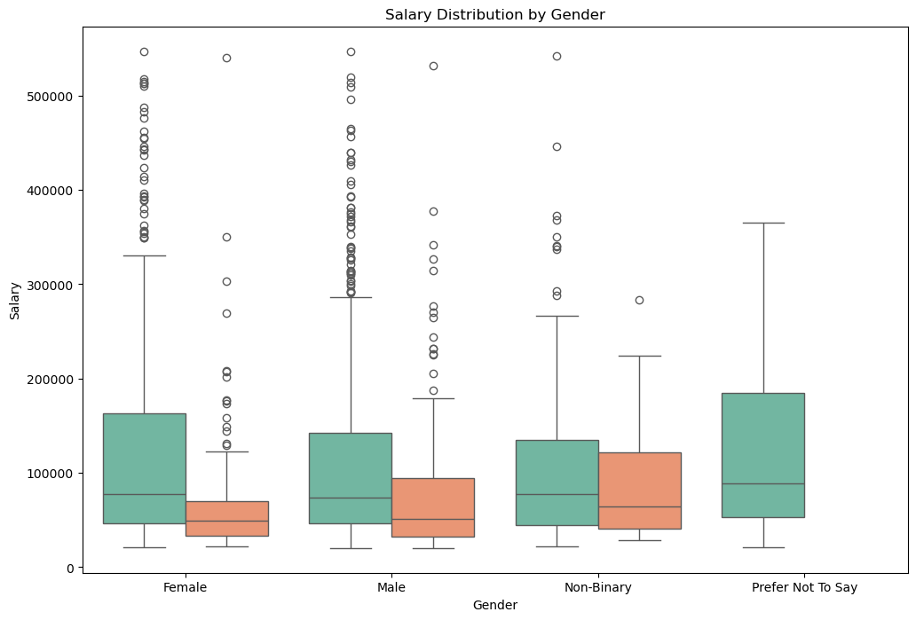



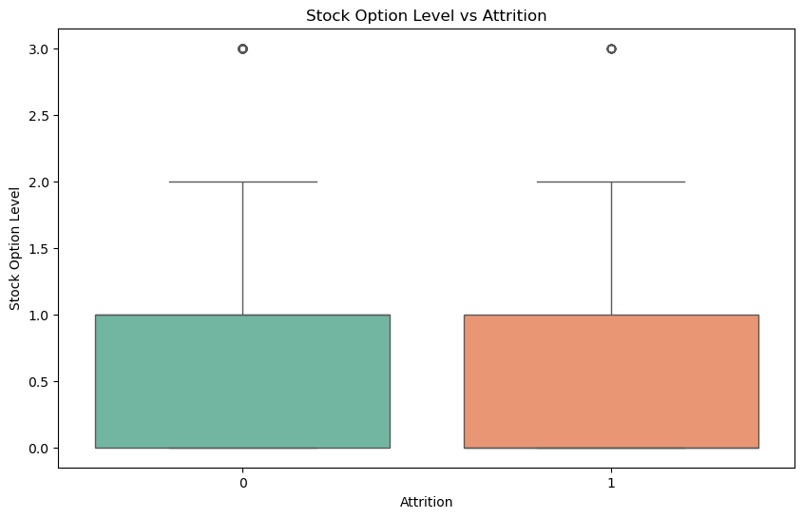

*3) Compensation Analysis:*

*Age Impact on Job Satisfaction and Attrition:*

* *How does job satisfaction vary across different age groups?*
* *What is the attrition rate for different age groups?*

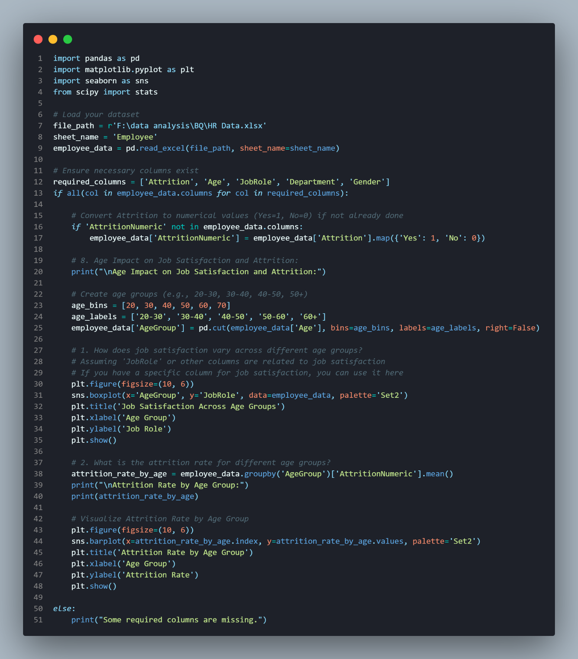

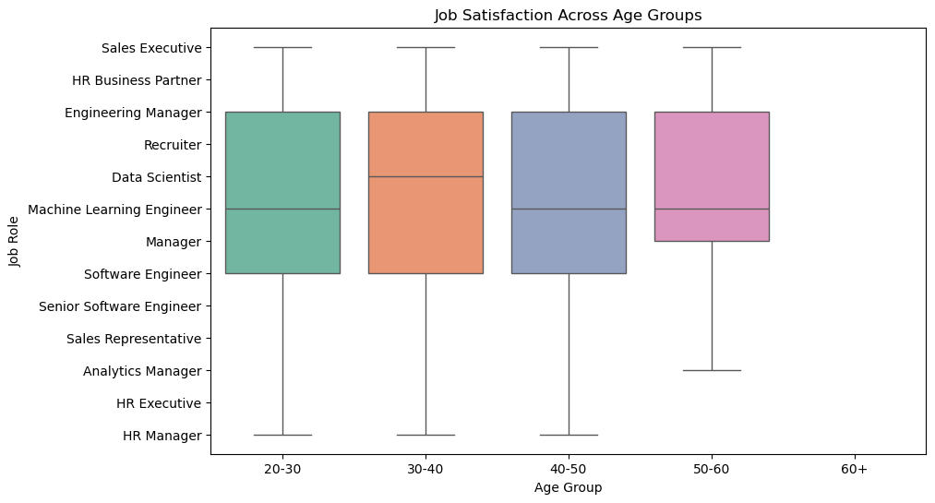

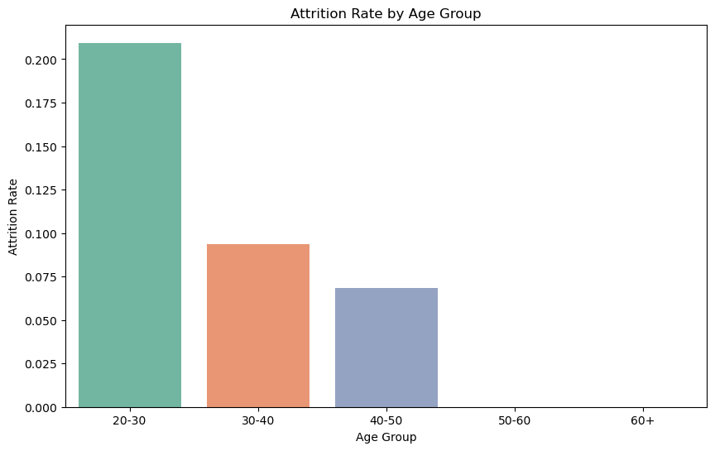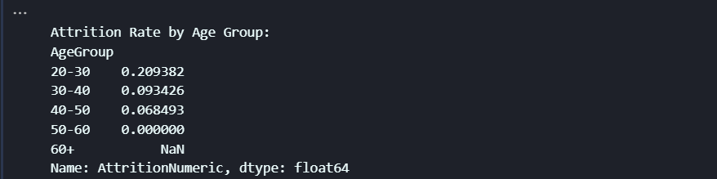

*3) Compensation Analysis:*

*Gender Differences in Job Satisfaction and Performance:*

* *How does job satisfaction vary between male and female employees?*
* *Is there a difference in performance ratings between male and female employees?*

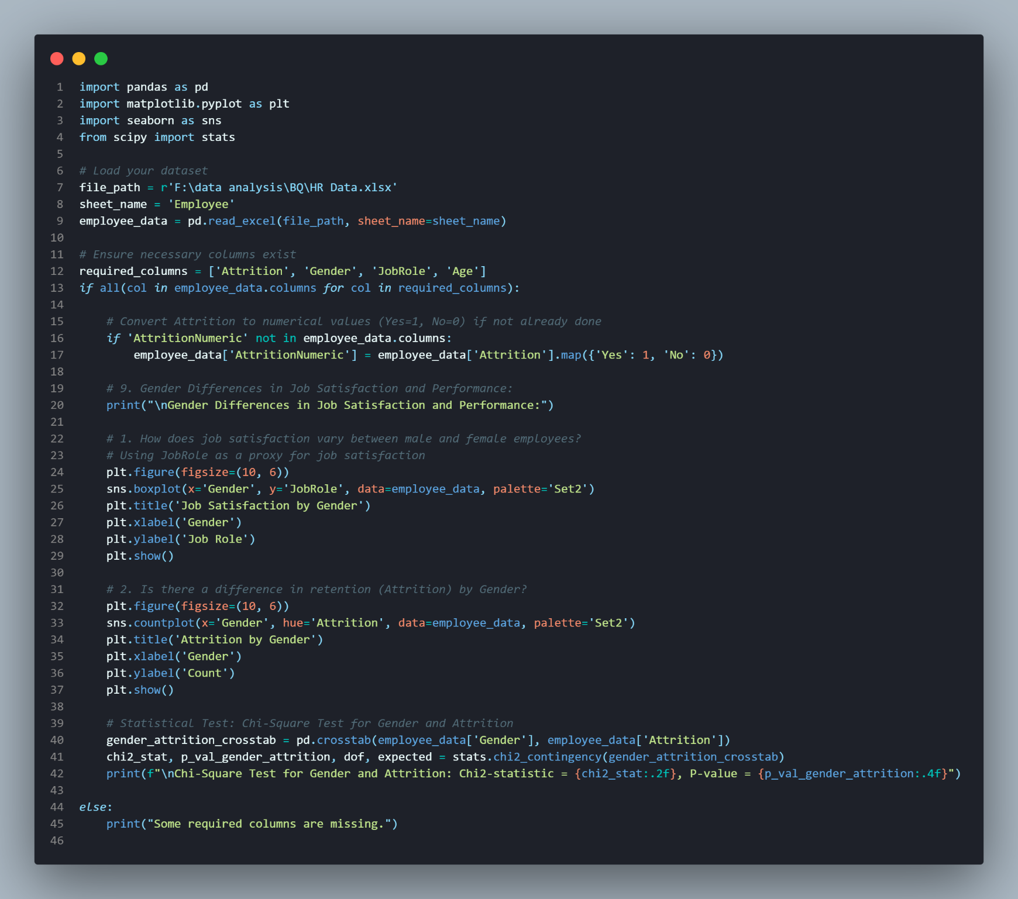

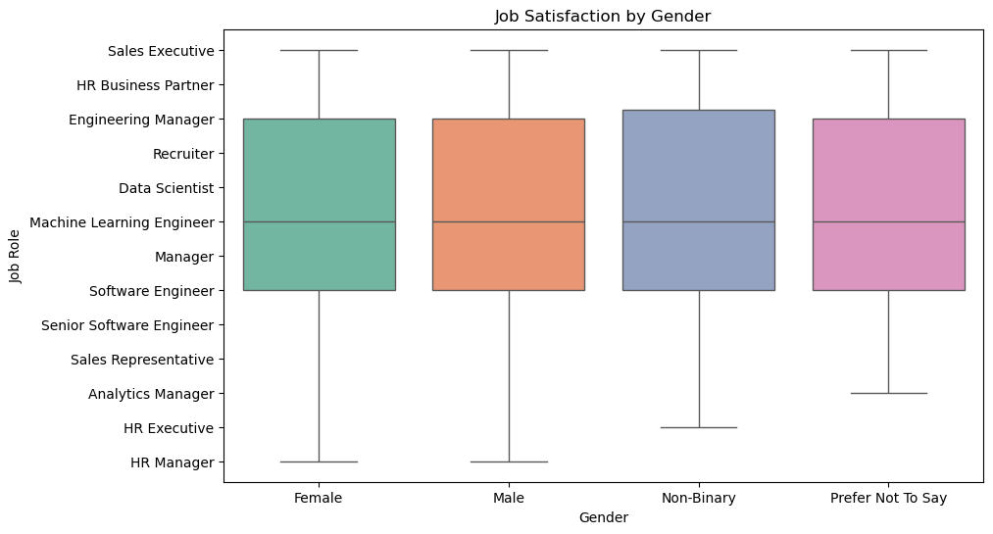

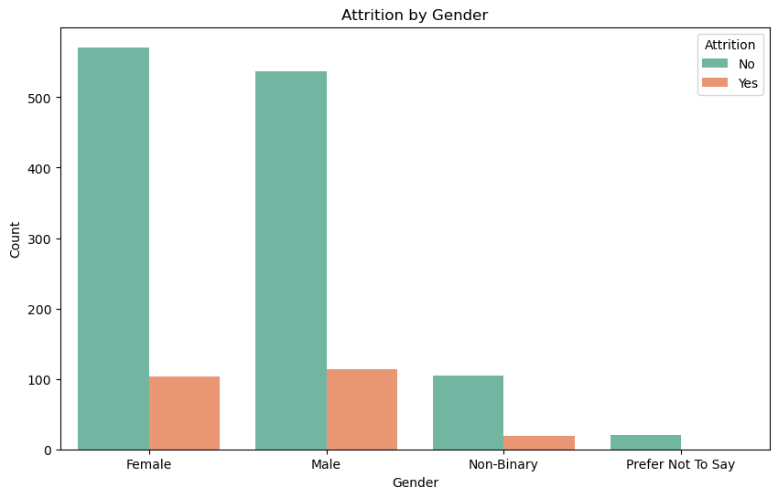



*3) Compensation Analysis:*

*Education Level and its Impact on Performance and Salary:*

* *How does education level influence employee performance and salary variation?*
* *How does education level impact employee performance?*
* *How does salary vary by education level?*
* *How does education level impact employee performance by manager rating?*

*Marital Status and Attrition:*

*How does marital status influence attrition rates and job satisfaction?*

* *Does marital status affect attrition rates?*
* *Is there a relationship between marital status and job satisfaction?*

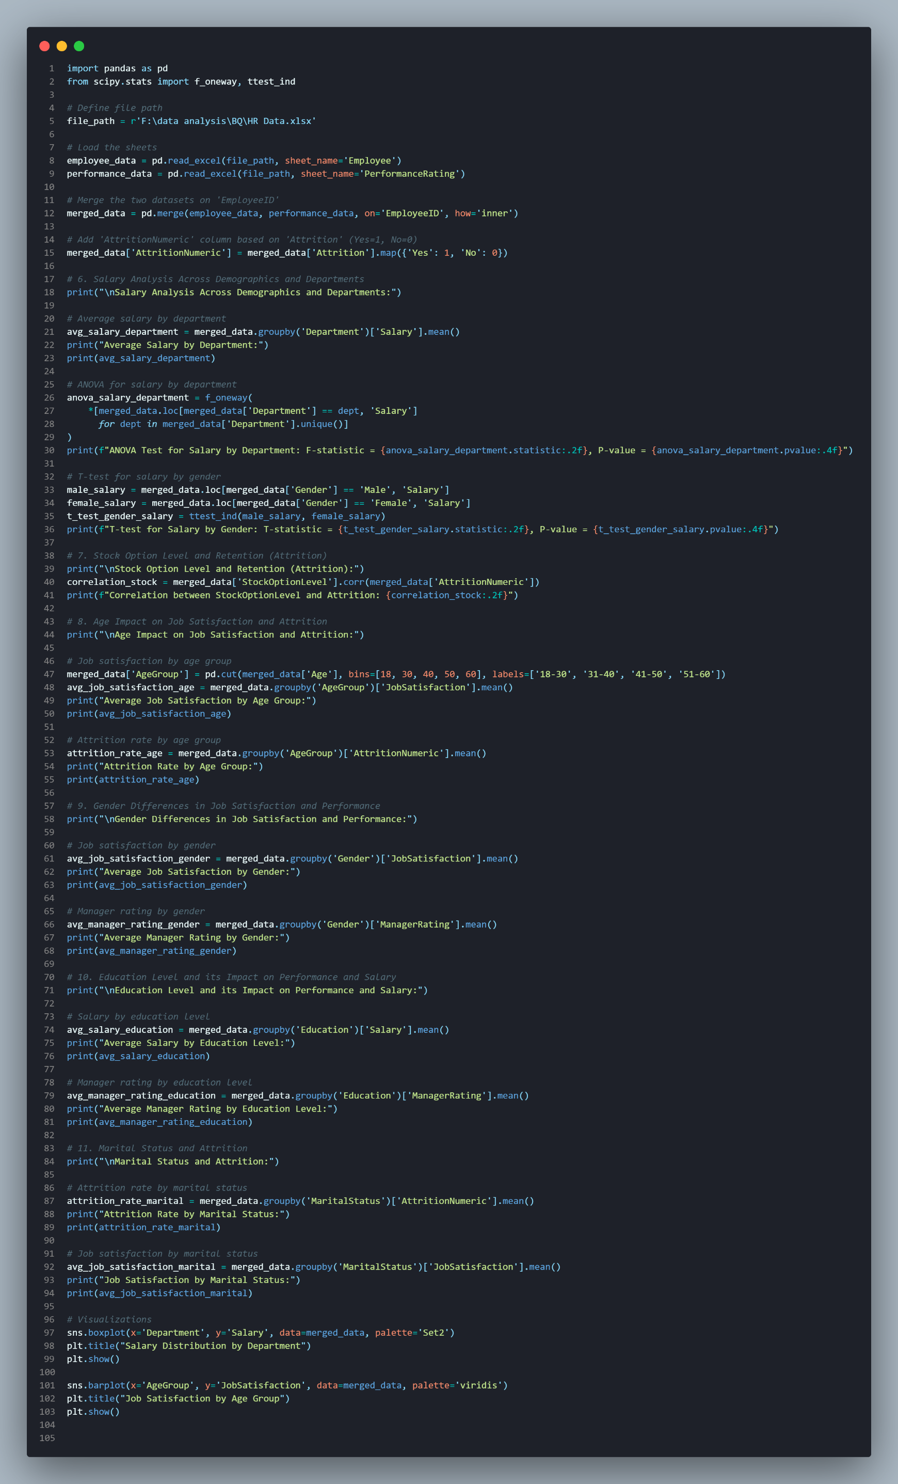

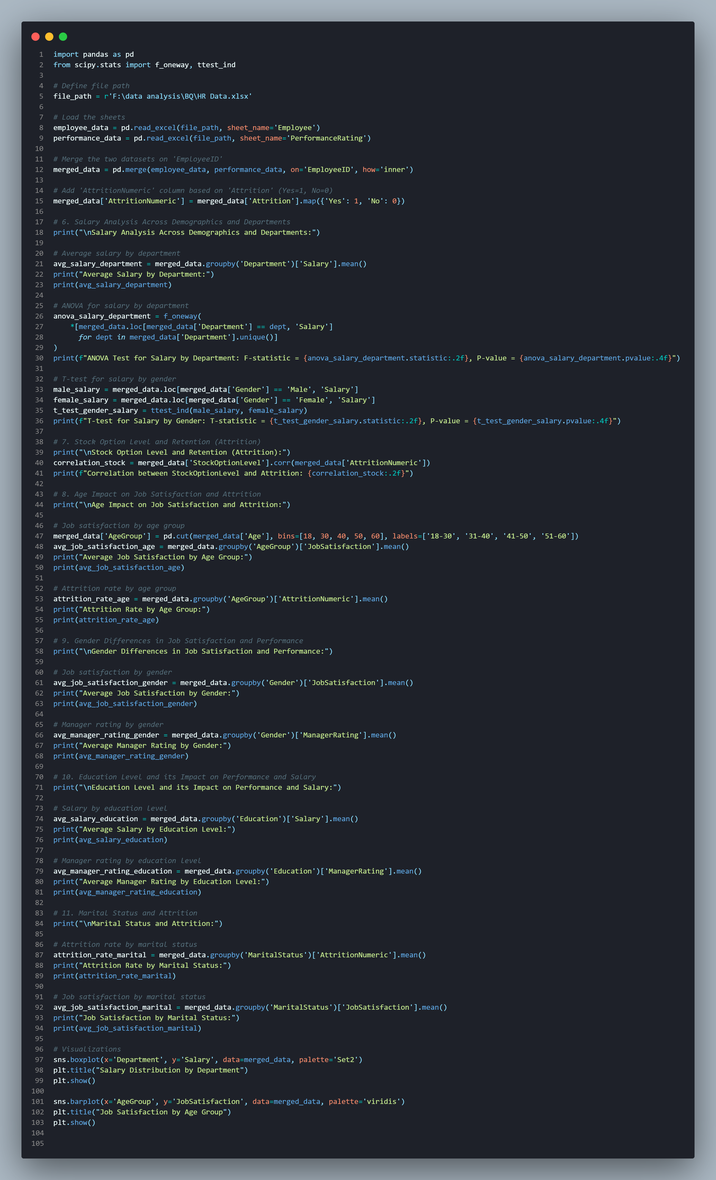

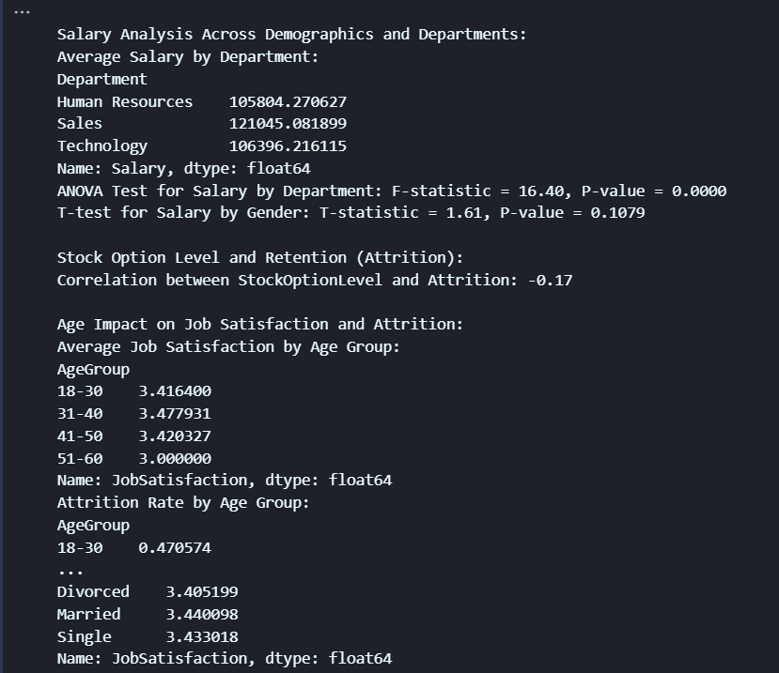

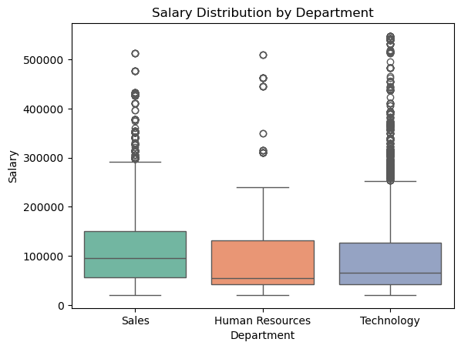

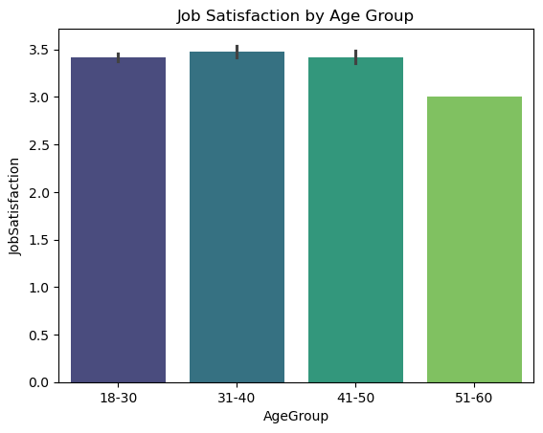

*2. Geographic Insights:*

*4) Work Environment:*

* *8 .Is there a correlation between overtime work and performance or attrition ?*
* *9 .How does business travel affect employee satisfaction and retention ?*

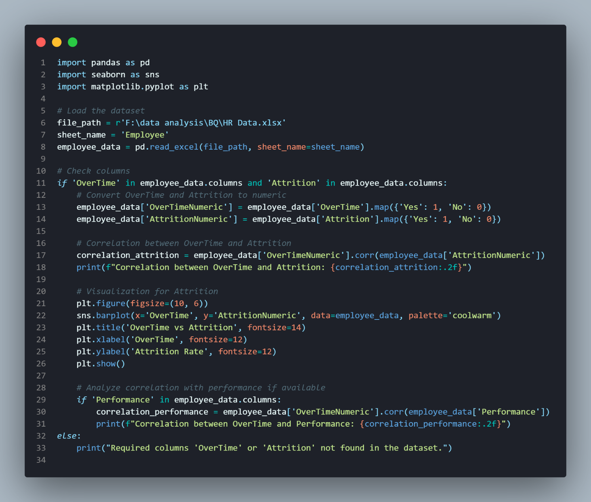



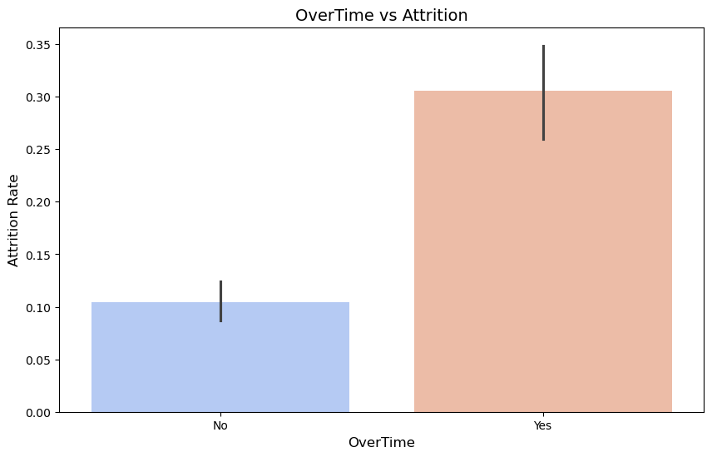

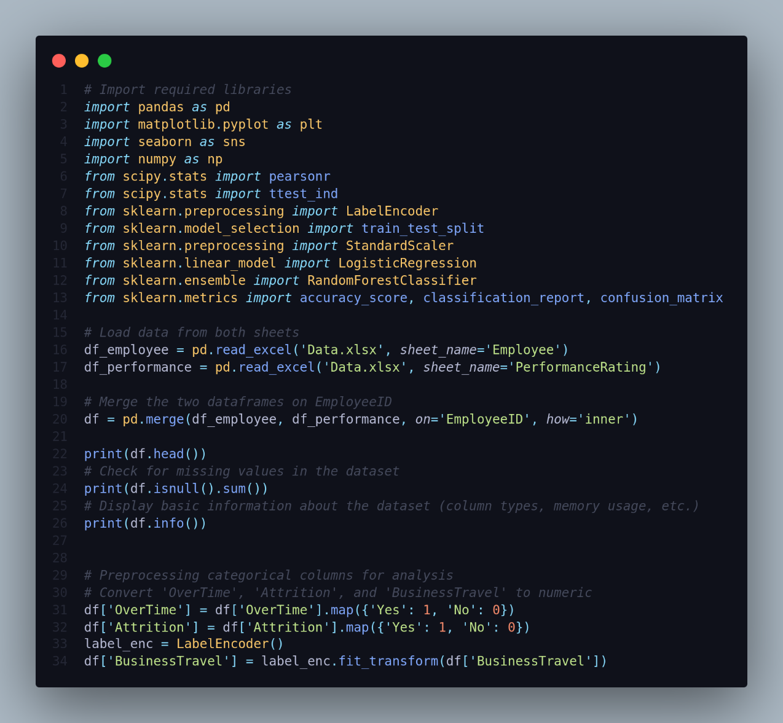

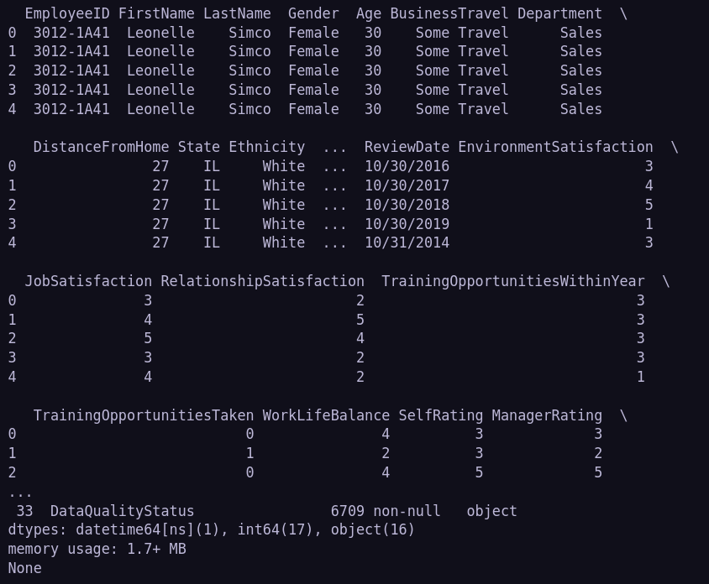

**2.Geographic Insights:**

18.Is there a correlation between overtime work and performance or attrition?

**Approach:** We'll analyze the relationship between `OverTime` and `Attrition`

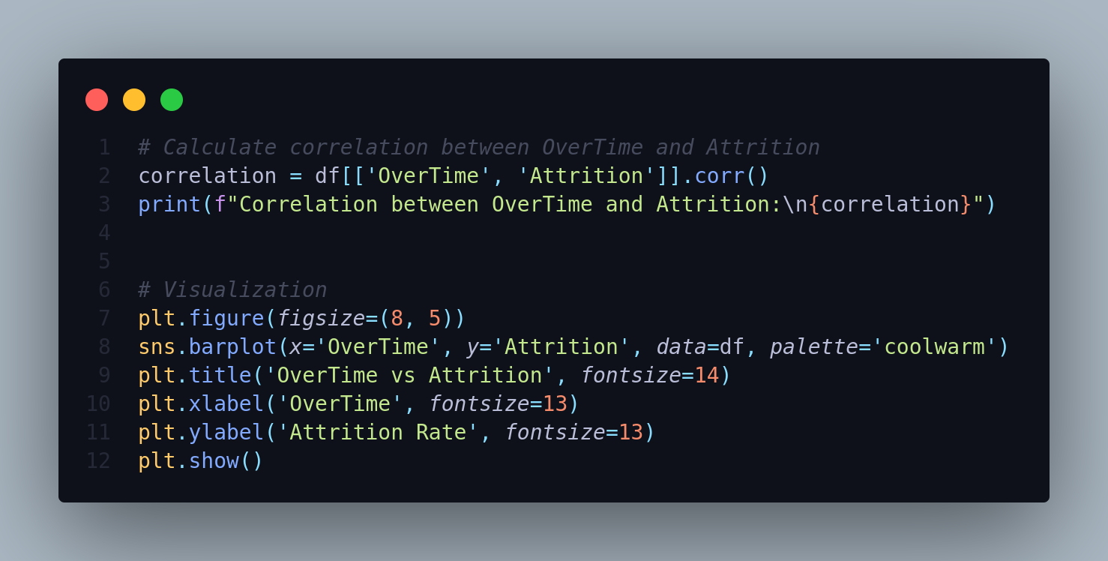

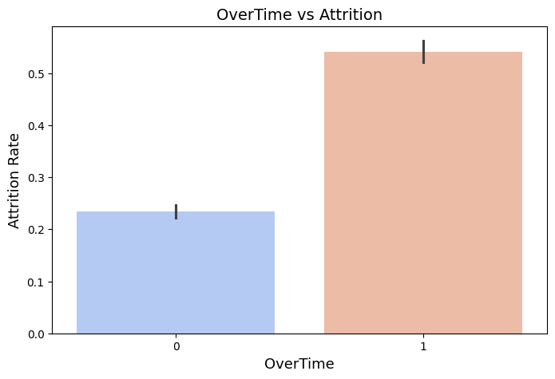

19.How does business travel affect employee satisfaction and retention?

We analyzed how `BusinessTravel` impacts `JobSatisfaction` and `Attrition` by computing their averages for each category and visualizing the trends using bar plots.

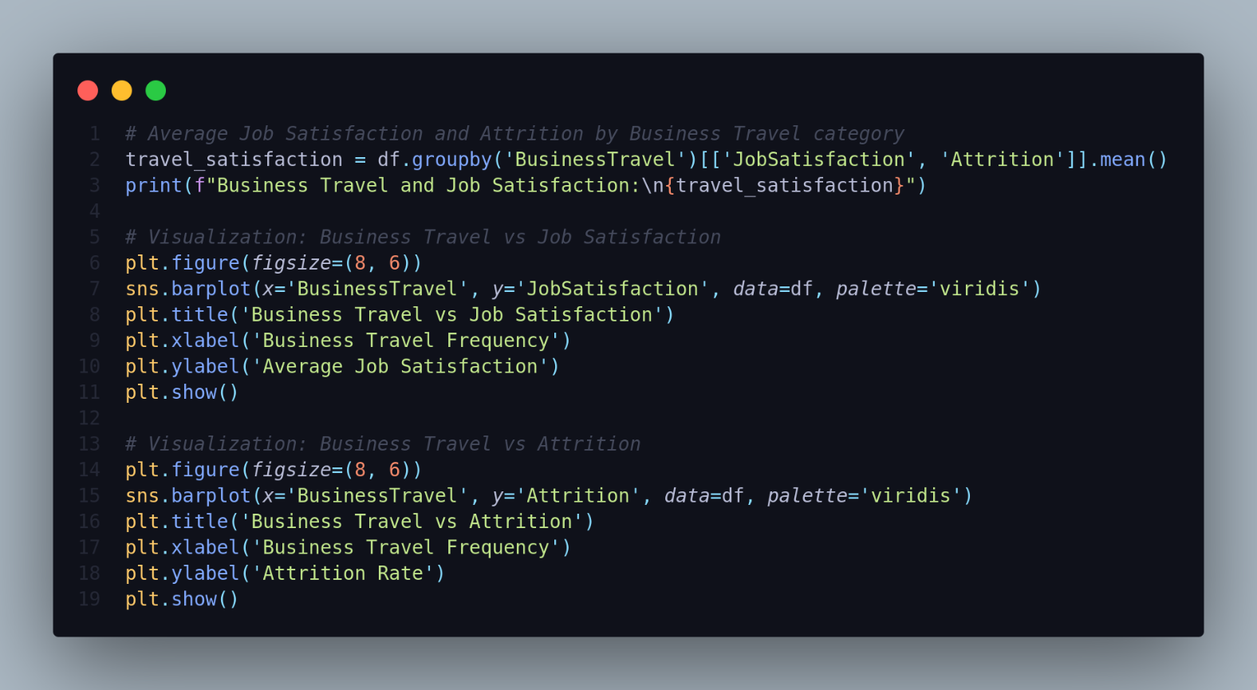



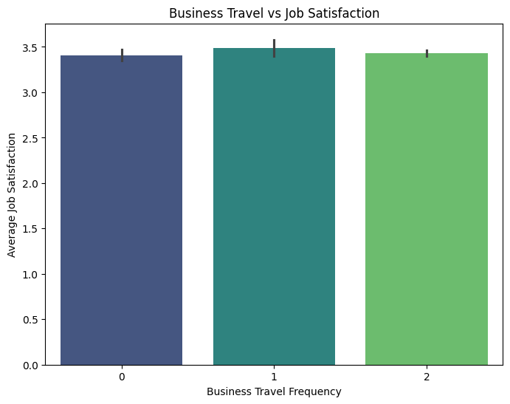

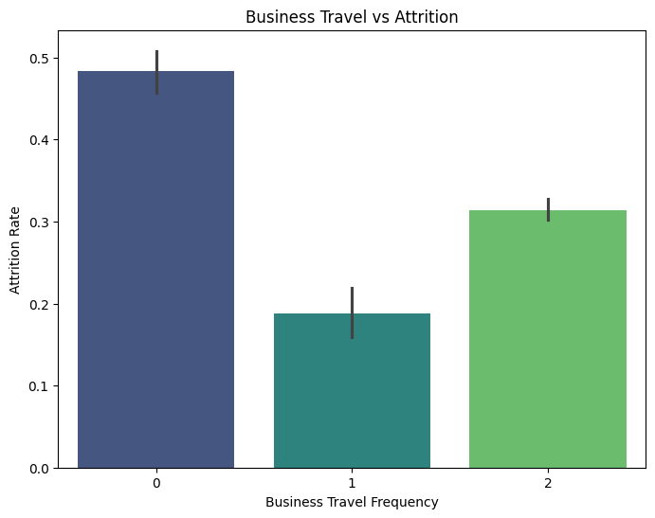

20.How does the distance from home affect job satisfaction?

We analyze the relationship between `DistanceFromHome` and `JobSatisfaction` by computing their correlation and visualizing the distribution using a box plot.

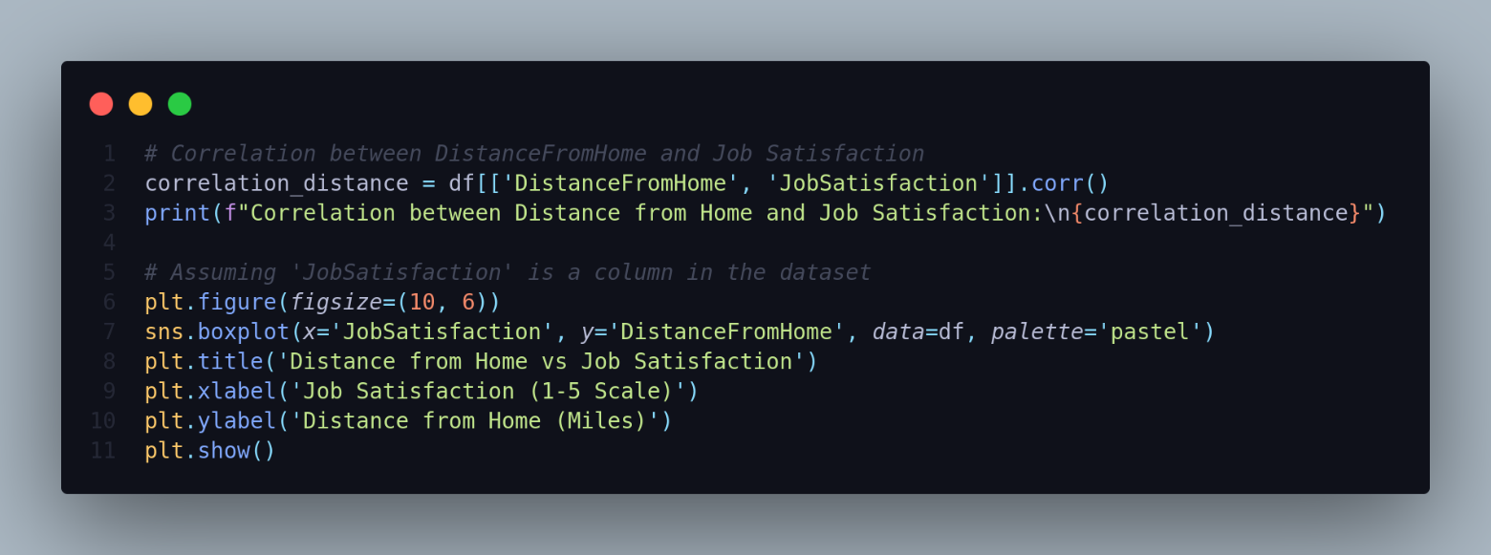

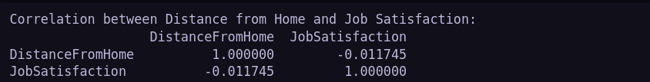

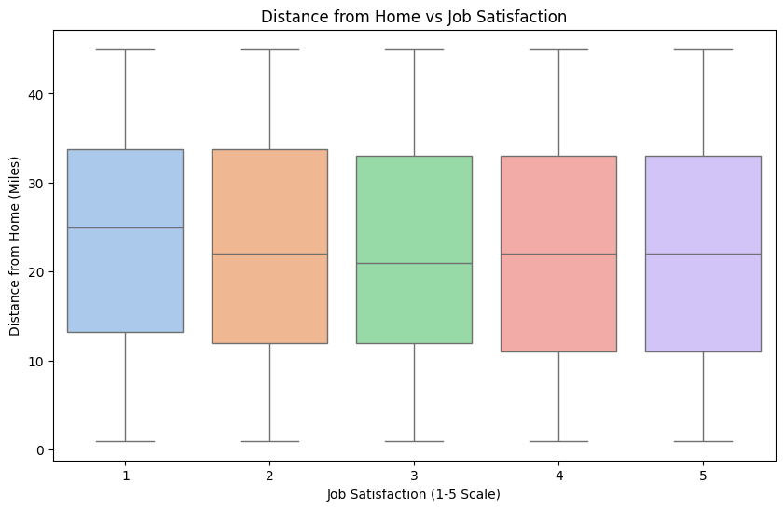

21.Which states have the highest and lowest attrition rates?

We’ll group by the `State` column and calculate the `attrition` rate for each state.

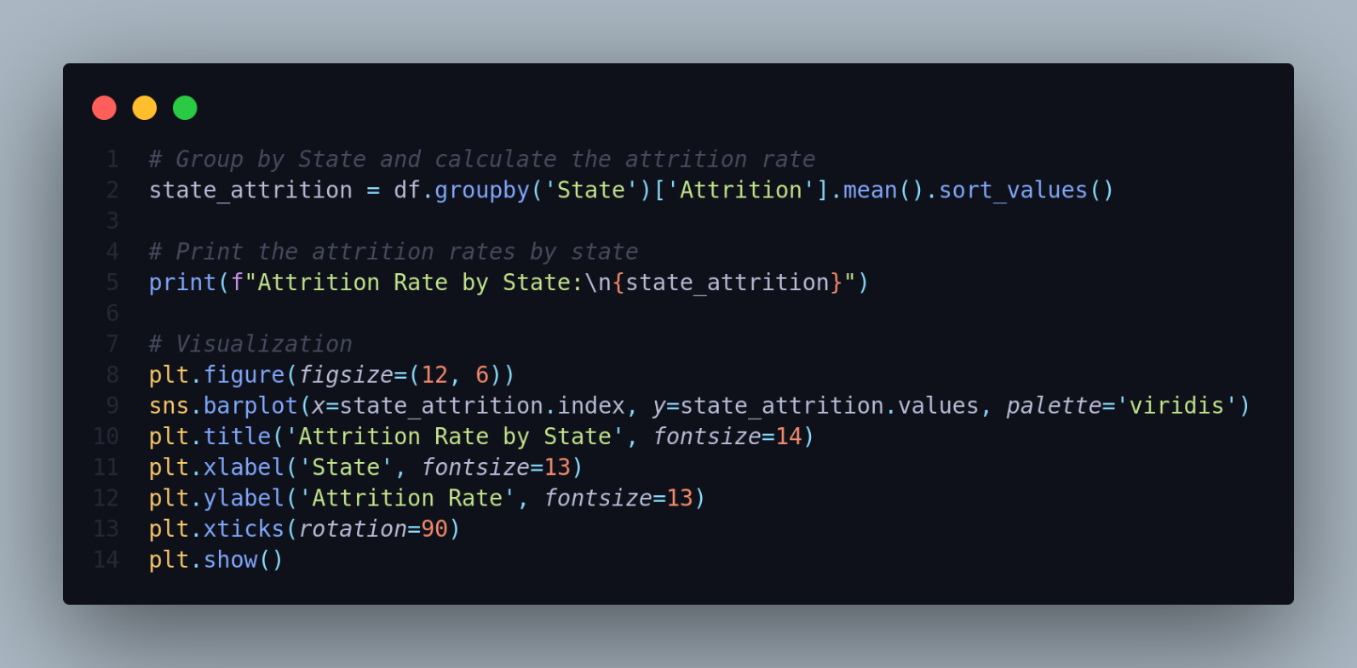



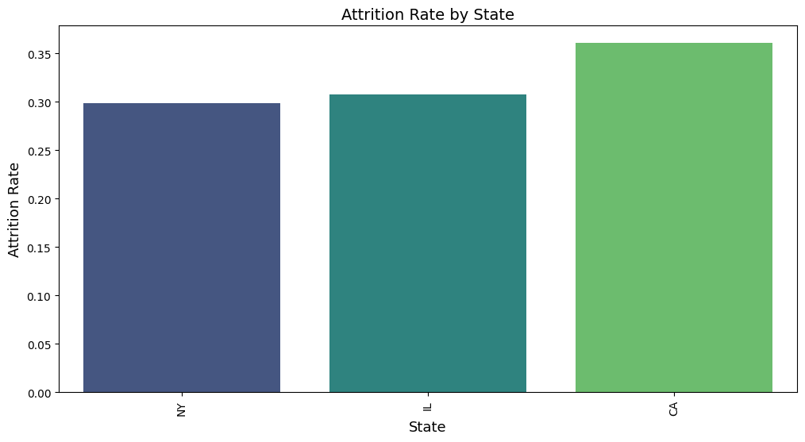

22.Which states have the highest percentage of employees leaving due to excessive overtime?

We can compute the `Attrition` rate among `OverTime` workers by filtering employees where `Attrition = 1` and `OverTime = 1`, then calculating the percentage per `State`.

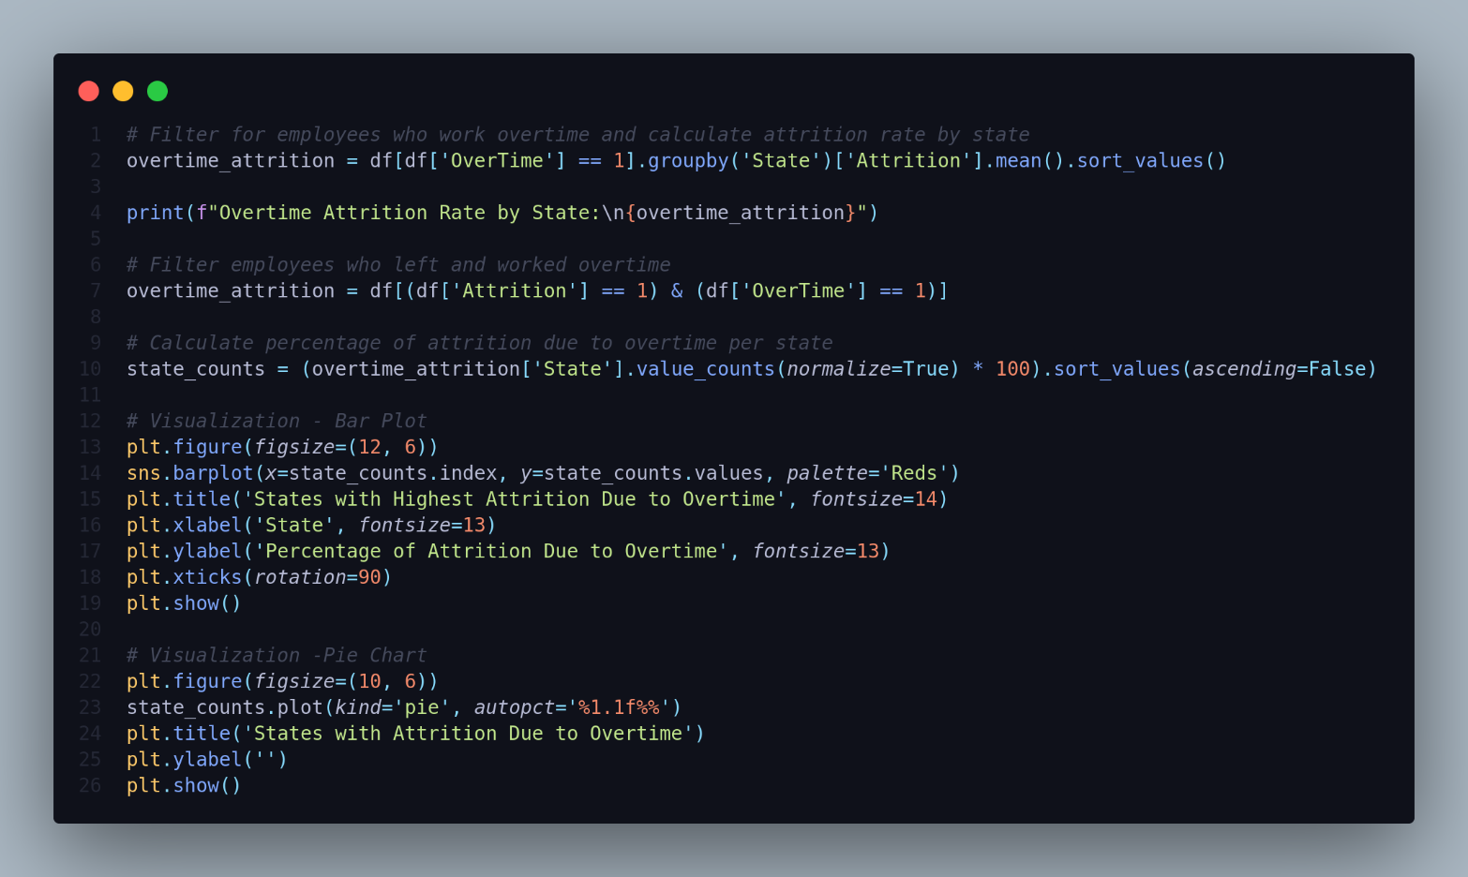

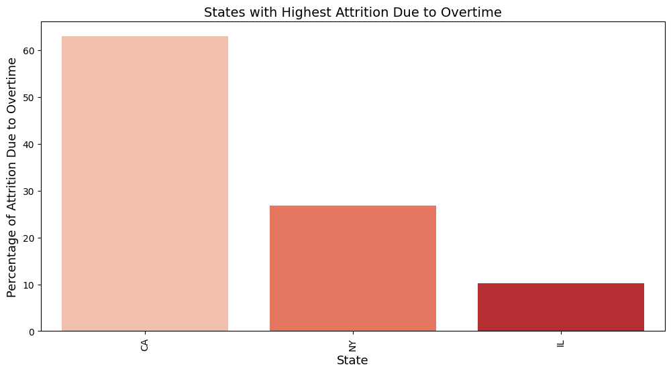

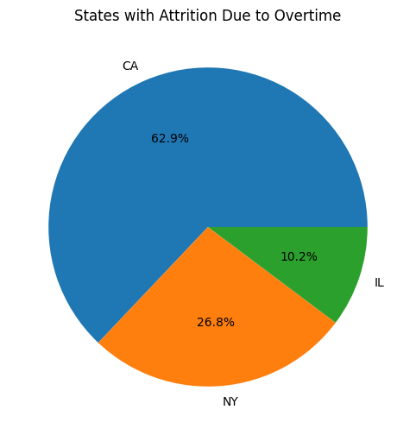

23.How does work-life balance affect overall job satisfaction?

We can use BusinessTravel to analyze its impact on `WorkLifeBalance` ratings and visualize the distribution of work-life balance across different business travel frequencies, while highlighting how `DistanceFromHome` relates to `ManagerRating` and how `WorkLifeBalance` influences JobSatisfaction.

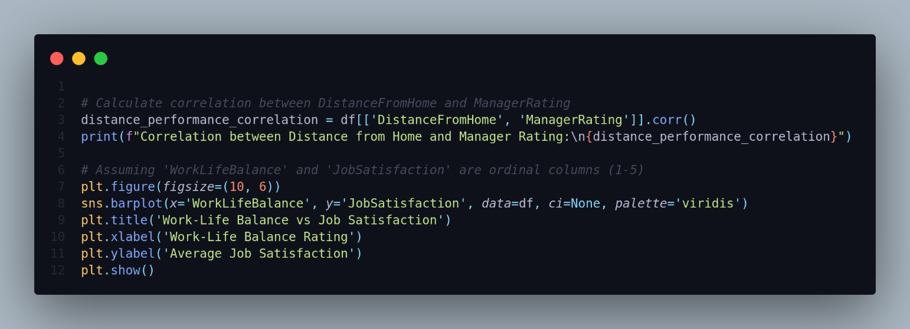

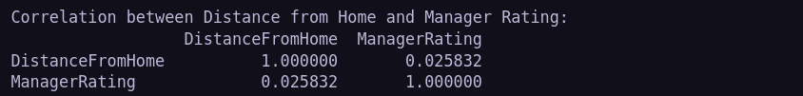

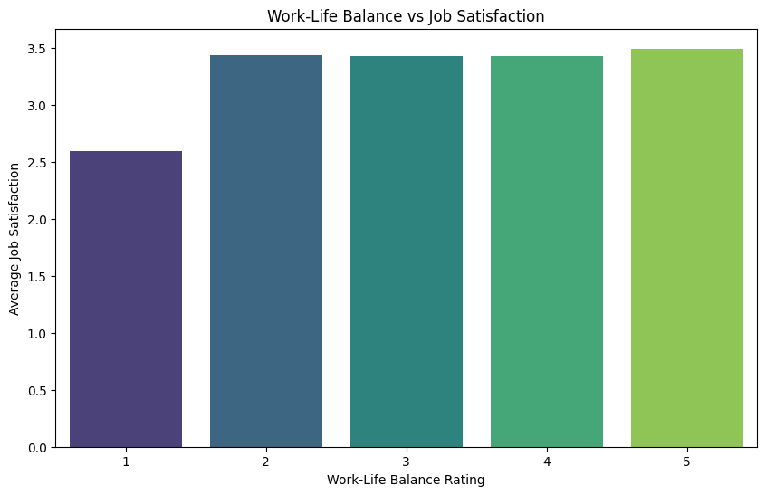

24.Is there a relationship between work-life balance and business travel frequency?

We can use `BusinessTravel` to analyze its impact on `WorkLifeBalance` ratings and visualize the distribution of work-life balance across different business travel frequencies.

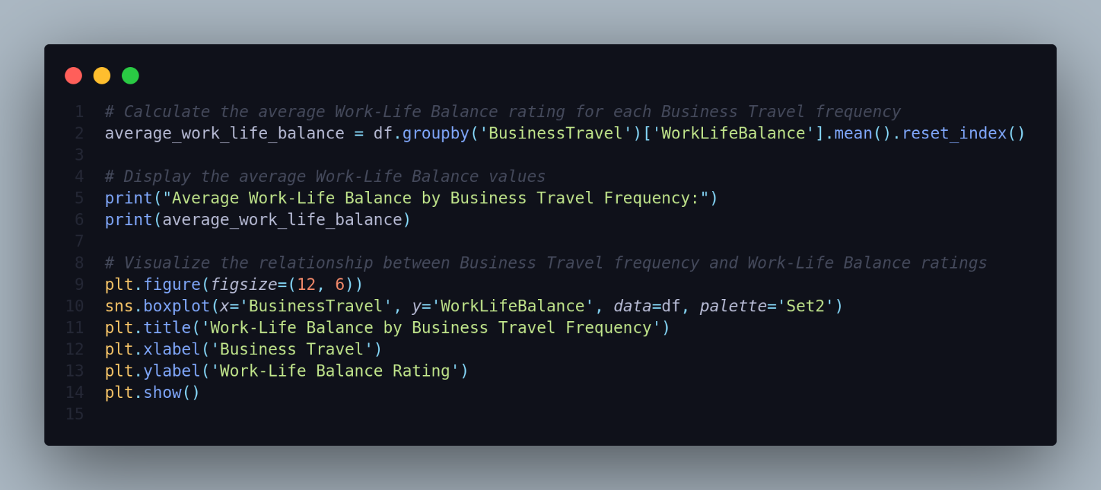

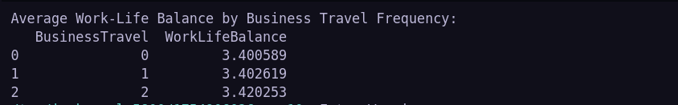

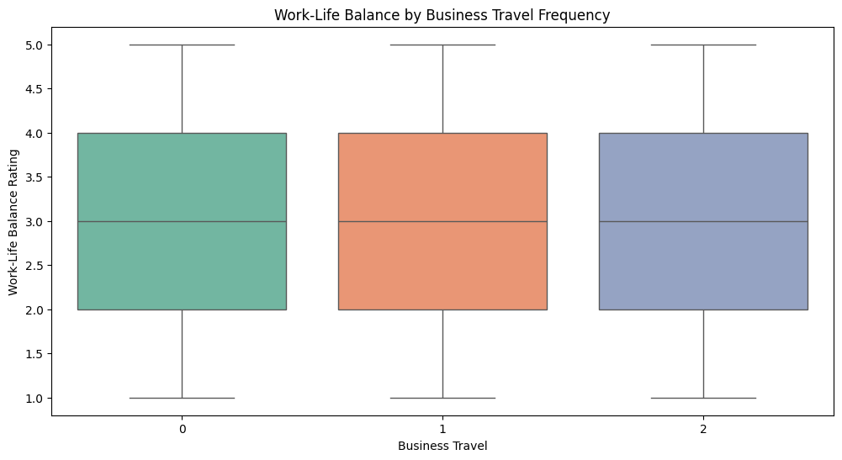

25.How does participation in training programs impact employee performance?

We can use `Education` as a proxy for training and skill level to analyze its impact on `Salary`.

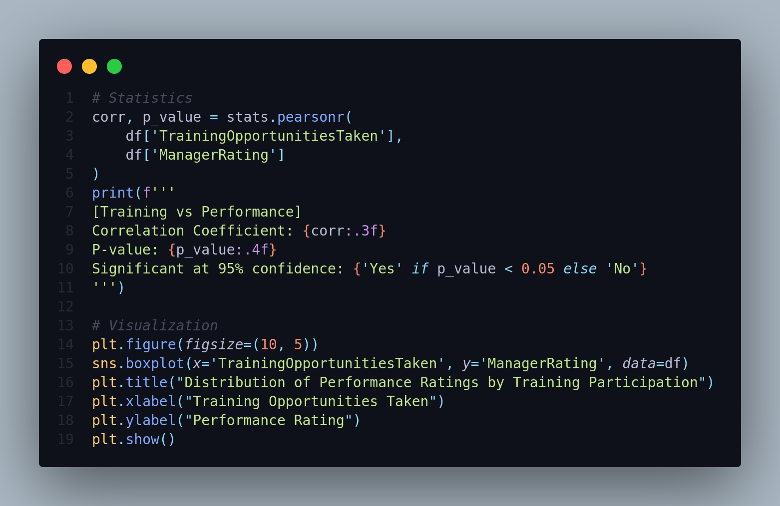

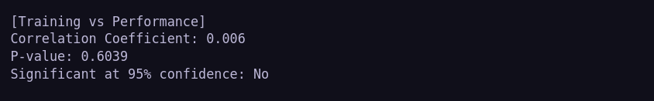

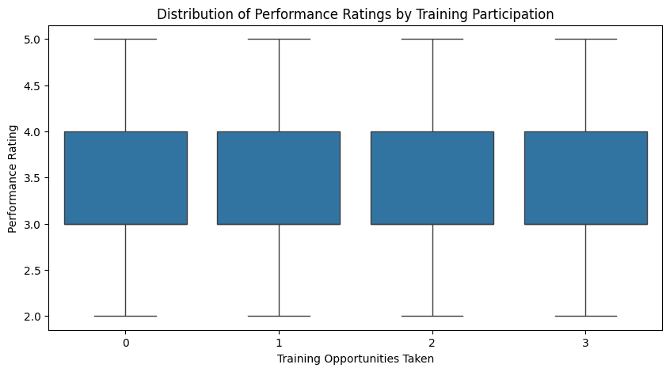

______________________________________________

26.Is there a connection between training and job satisfaction or promotion rates?

We can use `TrainingOpportunitiesTaken` to evaluate how training affects `JobSatisfaction` and `YearsSinceLastPromotion`.

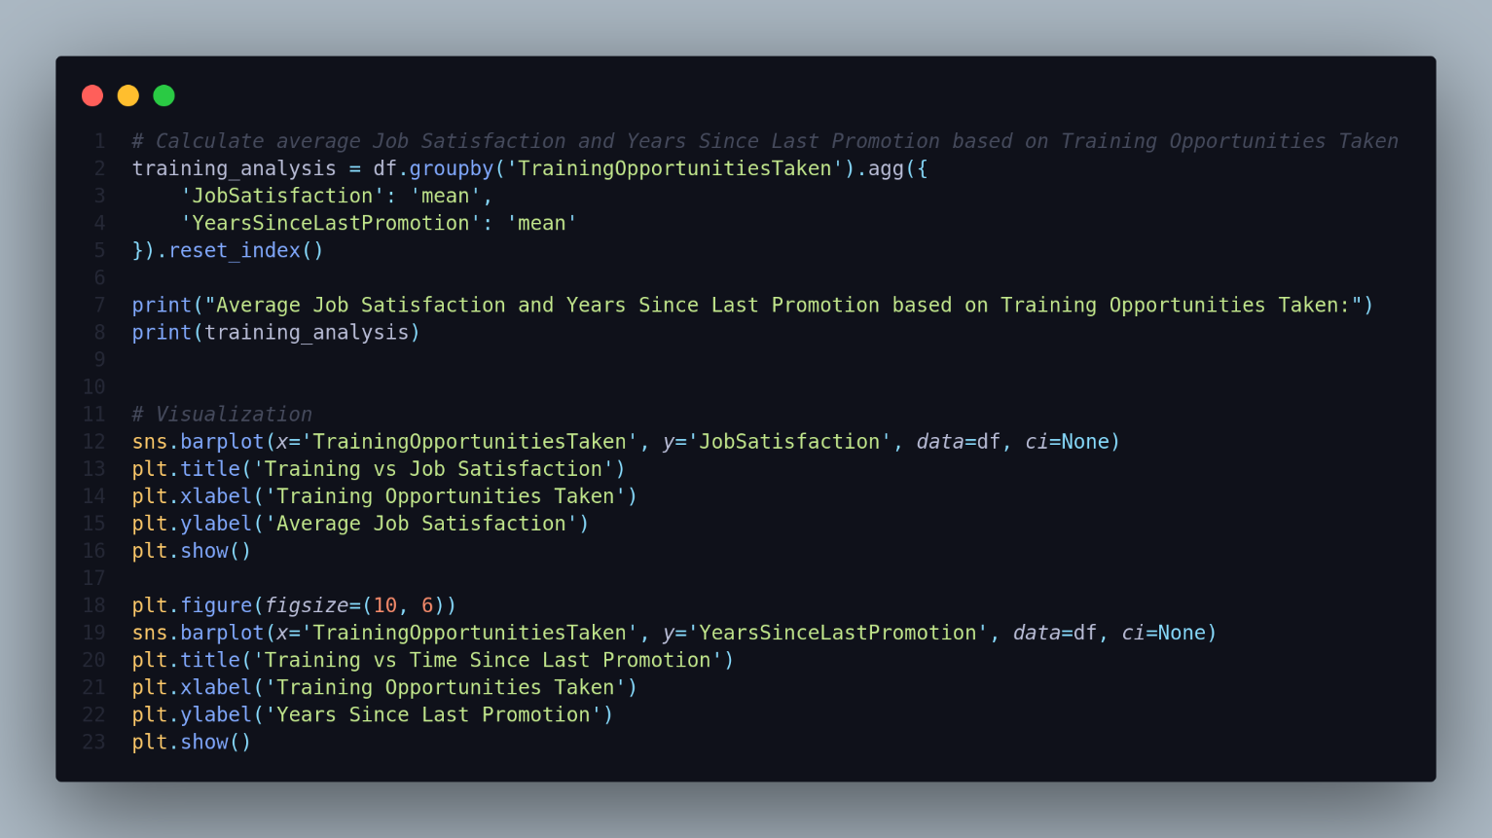

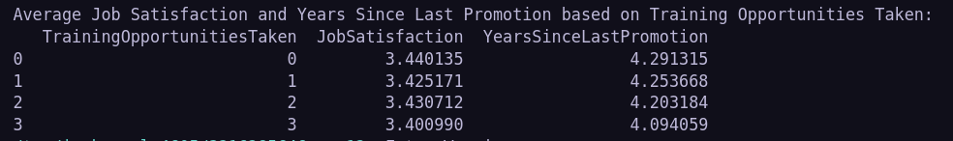

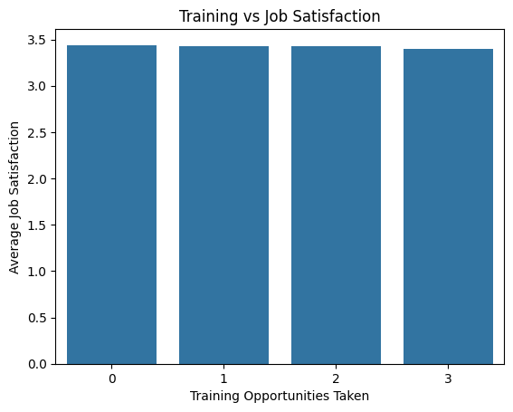

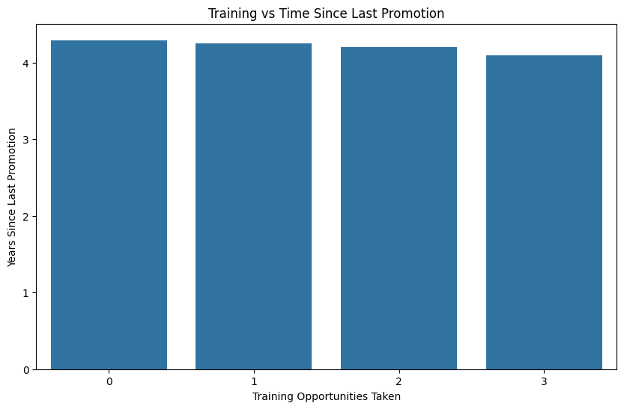

**4. Behavioral Insights:**

27.What are the trends in performance ratings across departments and demographics?

We will analyze how `PerformanceRating` varies across `Department` and `Gender`.

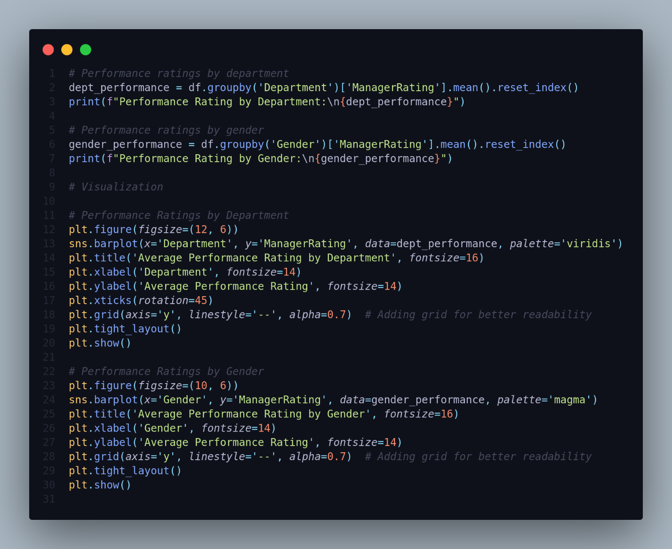

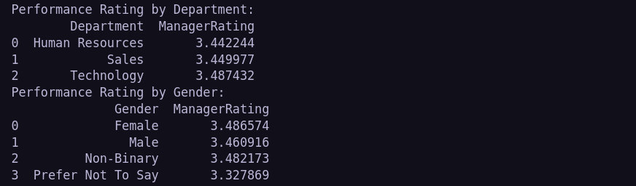

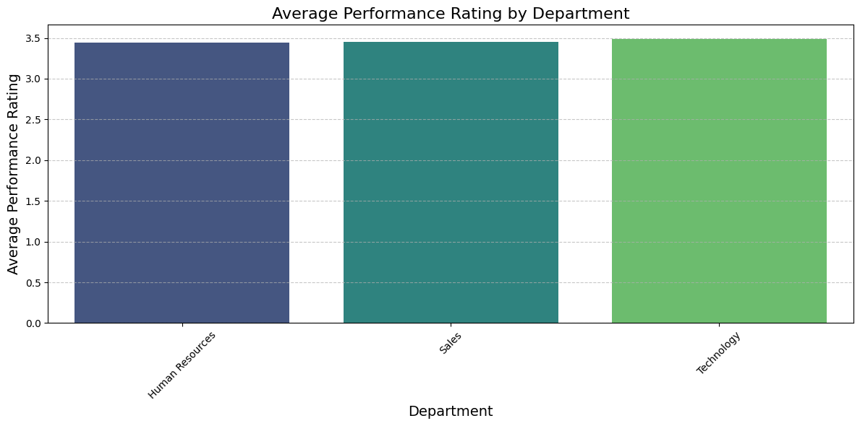

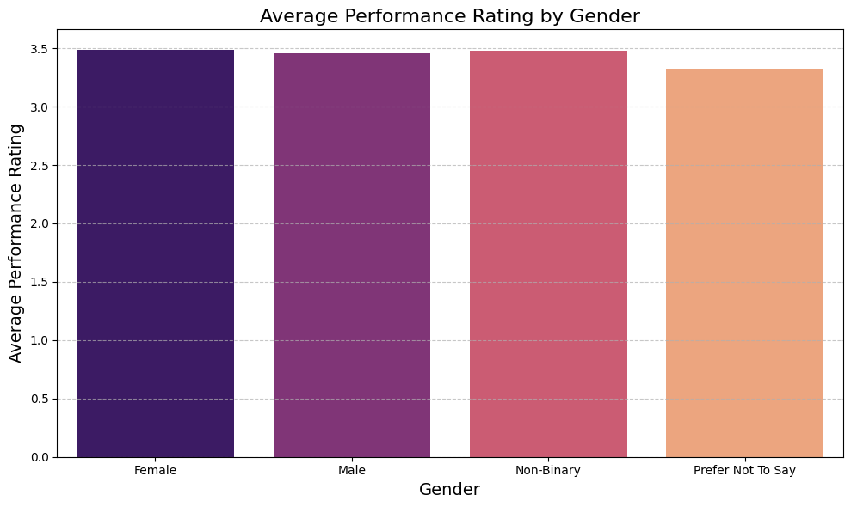

28.How does tenure (YearsAtCompany) impact performance and promotion rates?

To examine this, we can analyze how `YearsAtCompany` affects both `PerformanceRating` and `YearsSinceLastPromotion`.

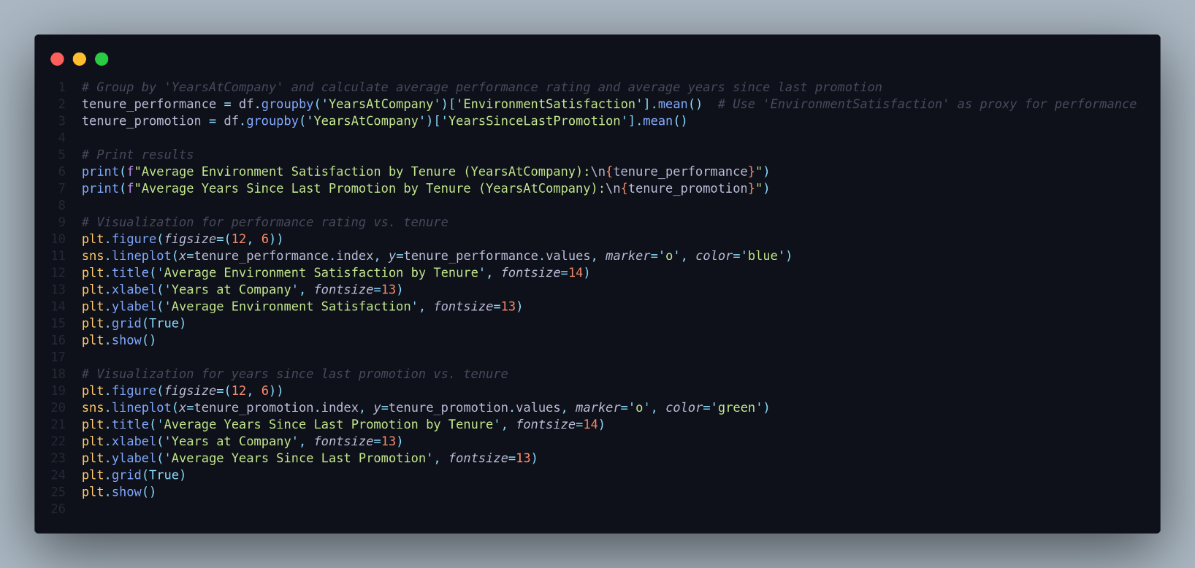

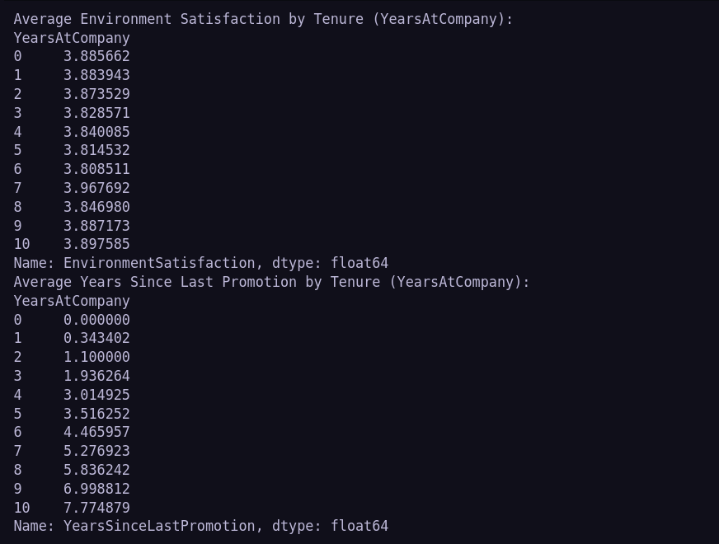

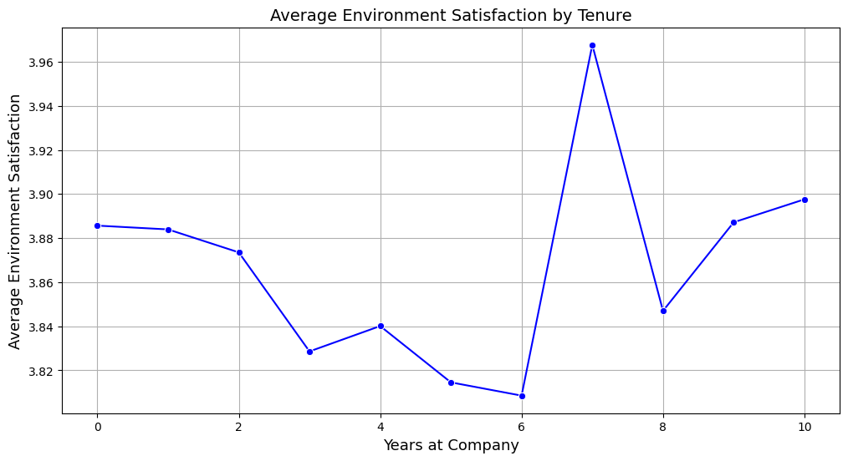

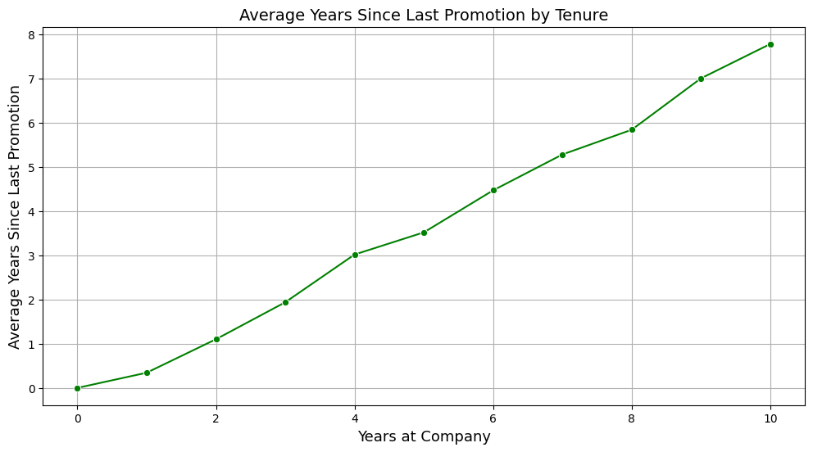

29.What is the average time to promotion for employees, and does it vary by department or gender?

We'll calculate the average `YearsSinceLastPromotion` and group the data by `Department` and `Gender`.

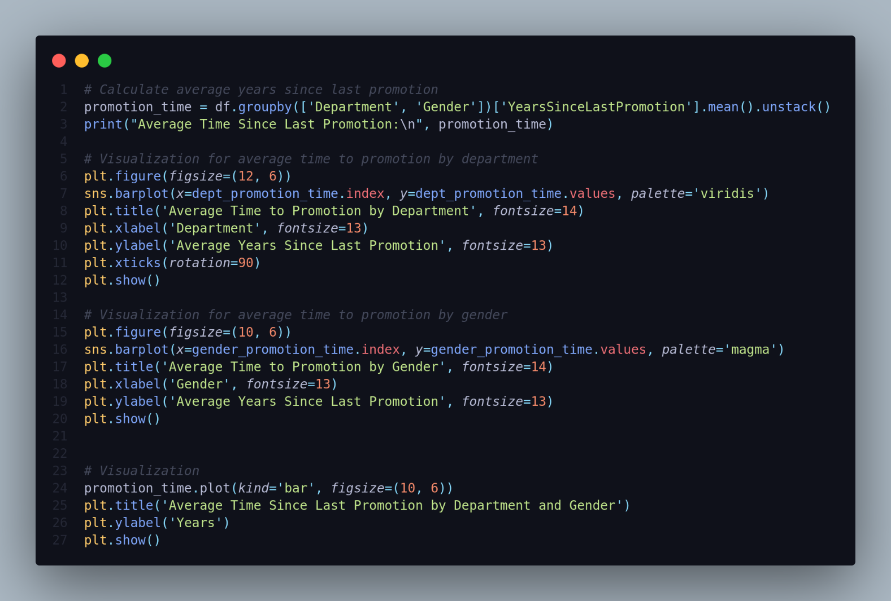



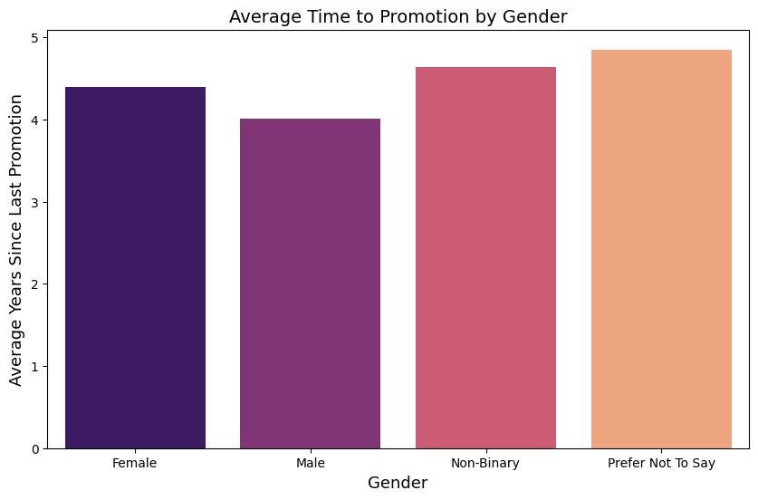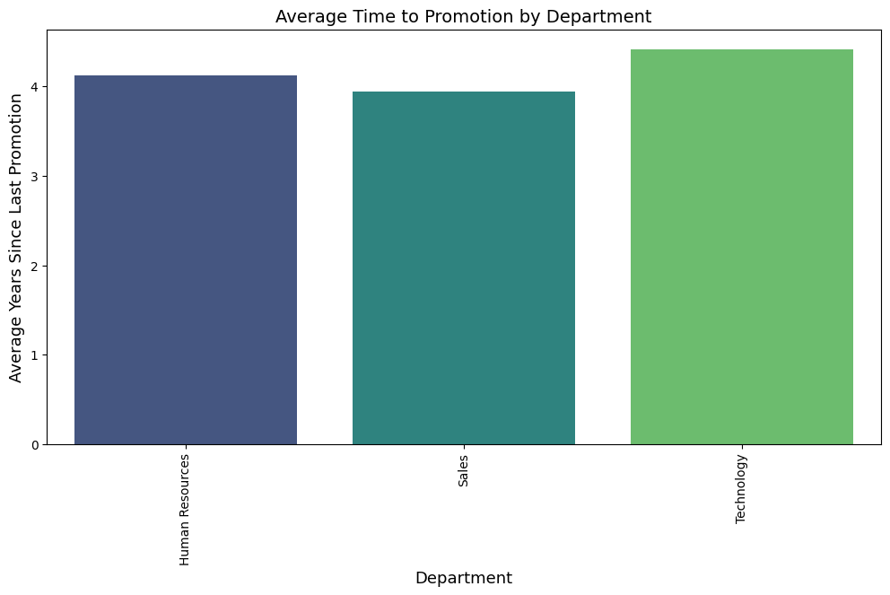

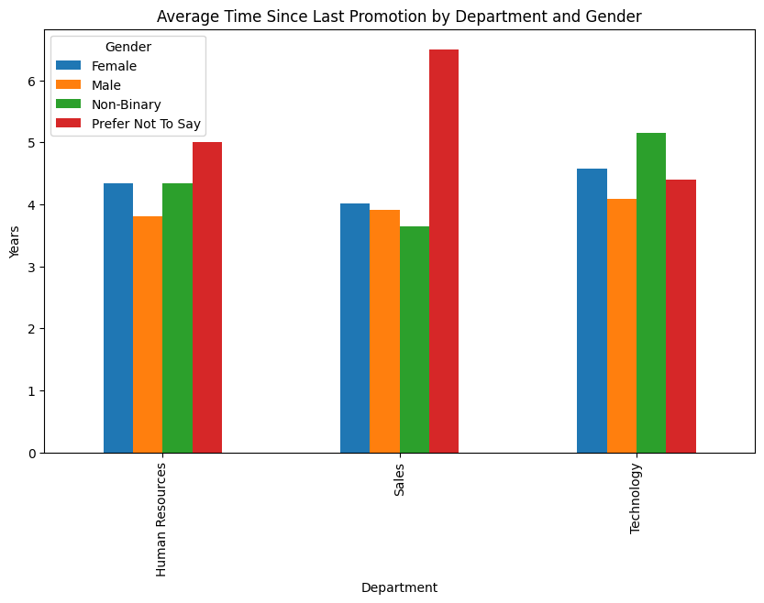

____________________________________________________

30.Are employees with longer tenure more likely to have higher performance ratings?

We analyze the correlation between `YearsAtCompany` and `ManagerRating` using regression and quartile-based grouping. Columns used: `YearsAtCompany`, `ManagerRating`, `TenureGroup`.

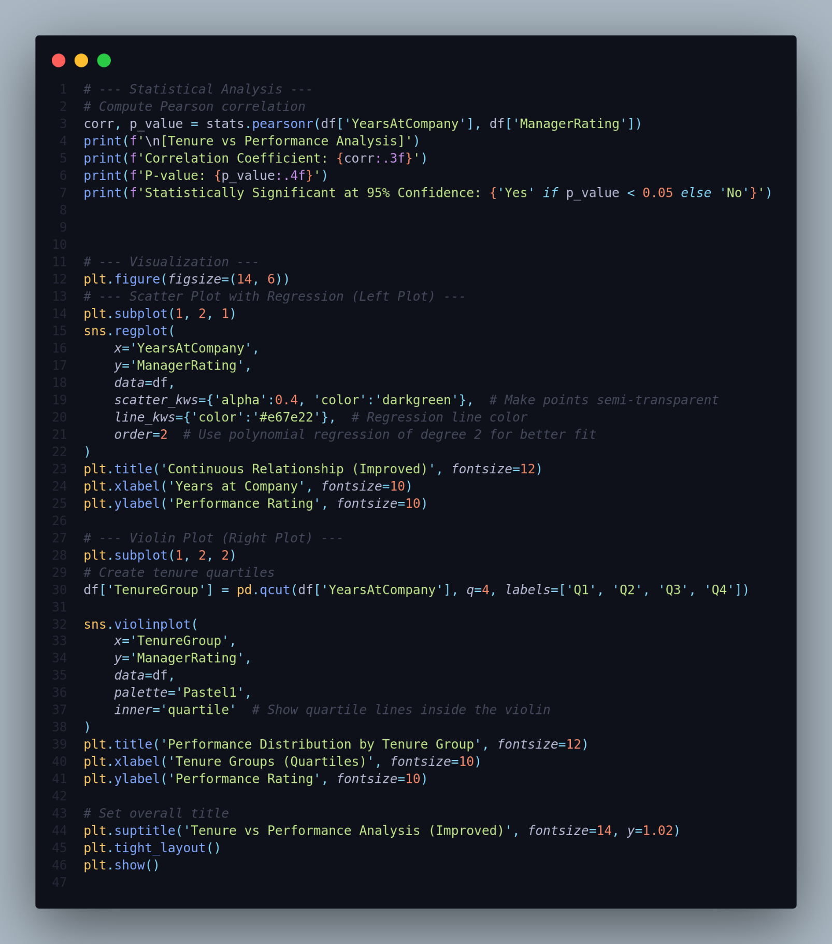

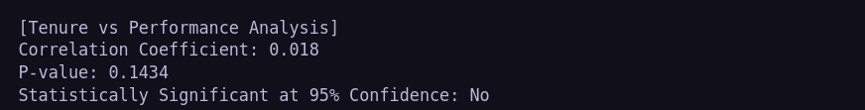

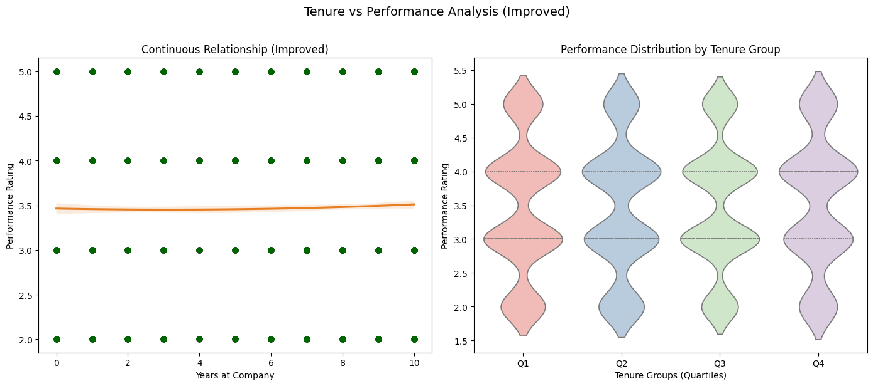

____________________________________________________

31.How does performance rating correlate with job satisfaction?

We can calculate the average `jobSatisfaction` for each `SelfRating` and create a boxplot to visualize the distribution of job satisfaction based on self-rating, highlighting differences based on attrition status.

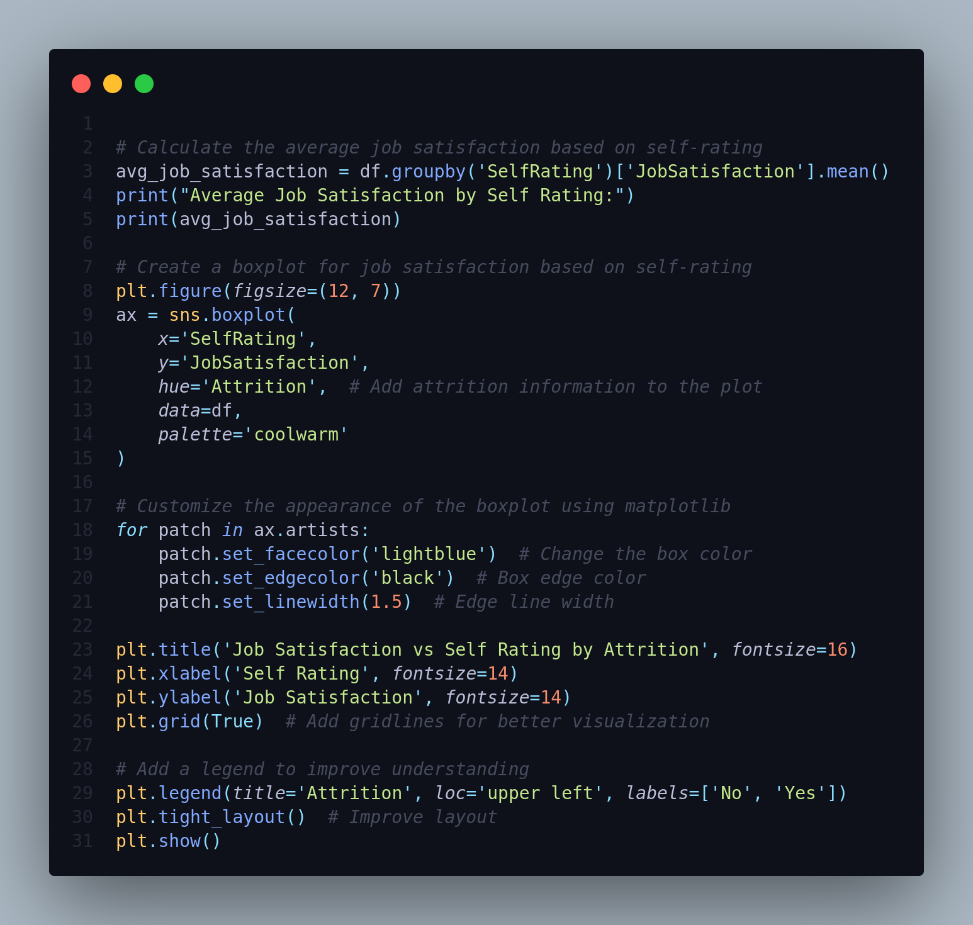



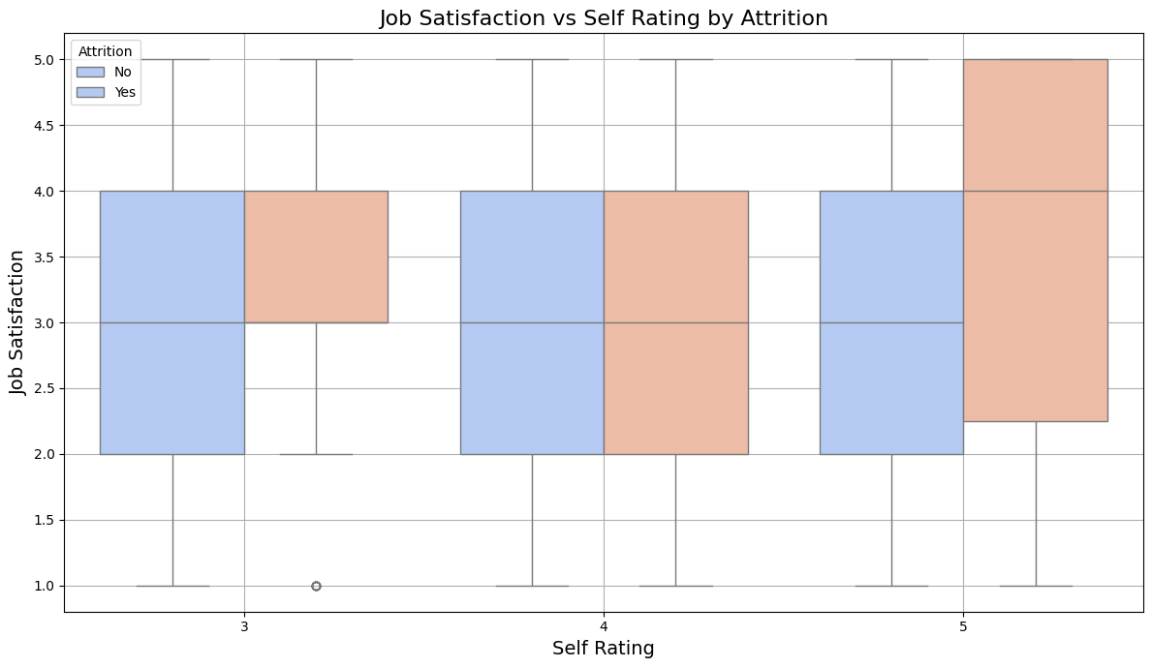

____________________________________________________

32.What is the attrition rate for employees with different performance ratings?

We can group the data by `PerformanceRating` and calculate the attrition rate for each rating level.

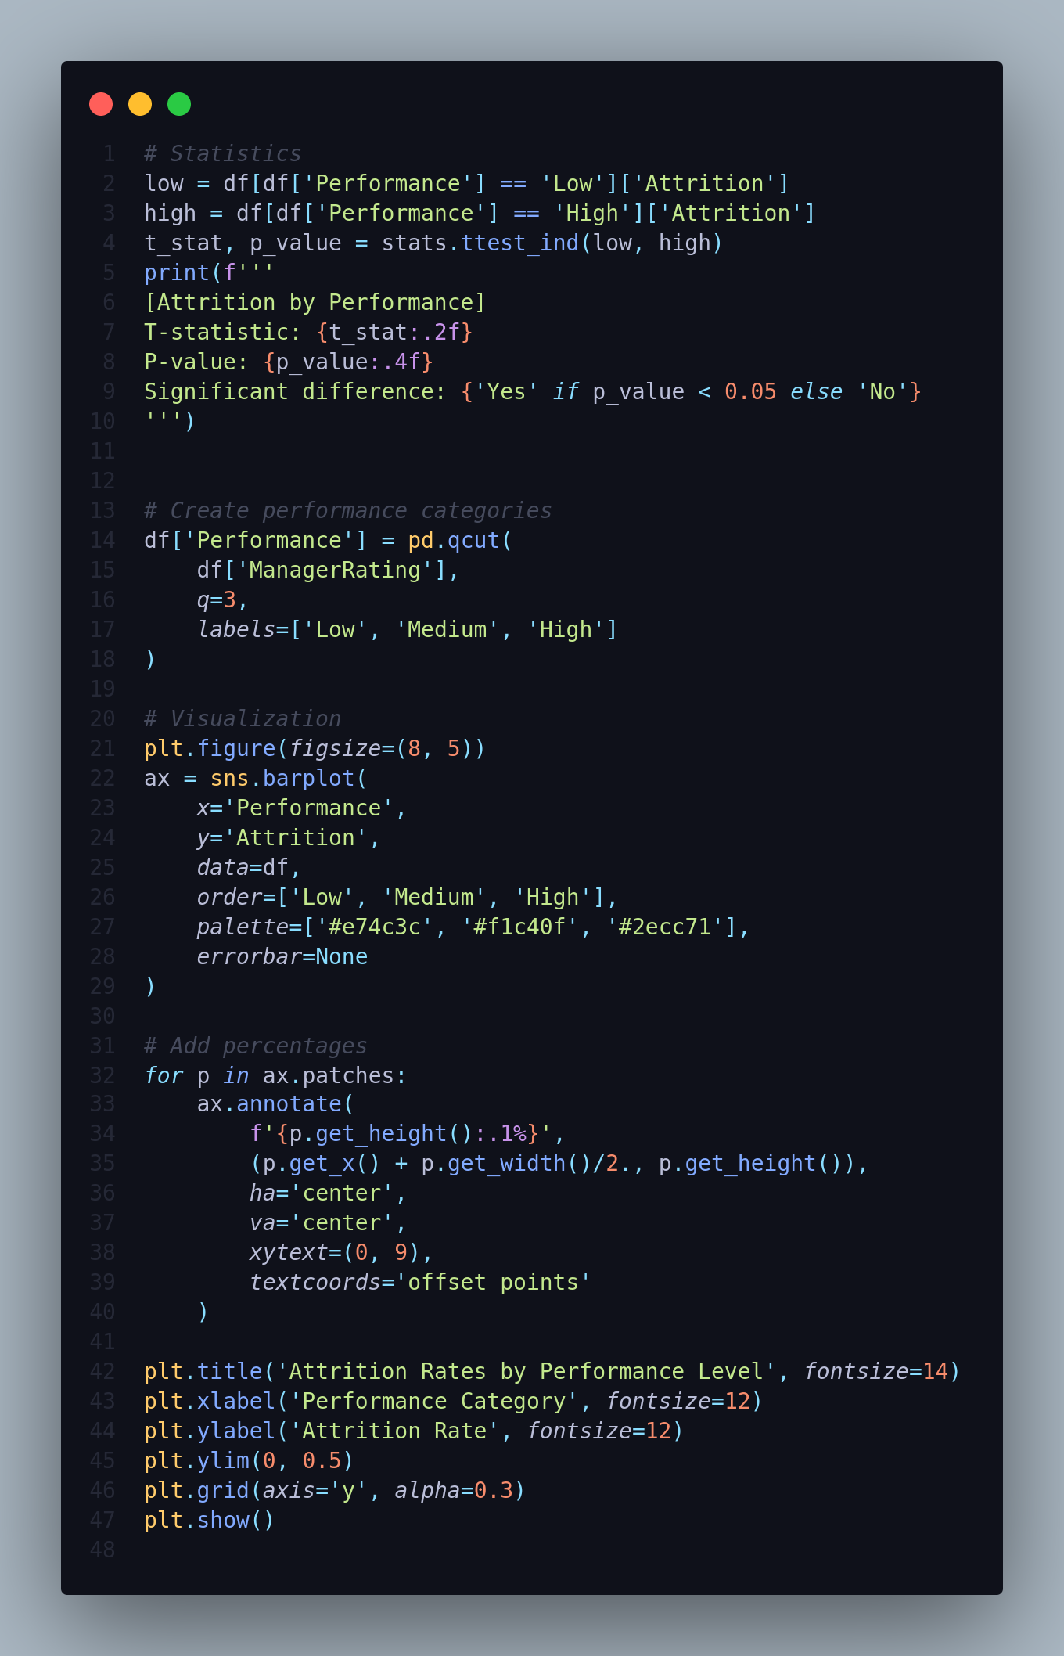

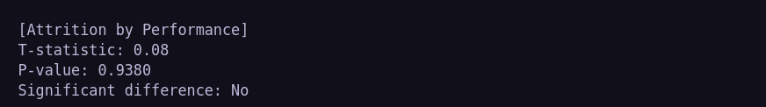

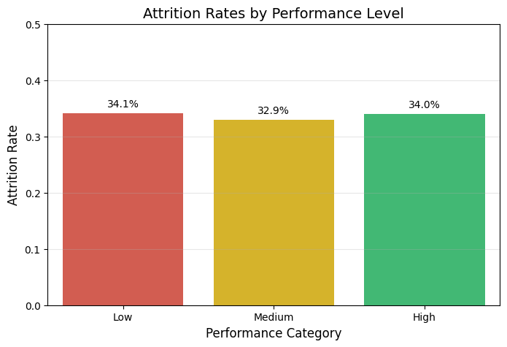

____________________________________________________

33.What is the impact of overtime on job satisfaction?

Since we do not have a direct measure of job satisfaction, we can analyze the impact of `OverTime` on `PerformanceRating` and use that as a proxy for satisfaction.

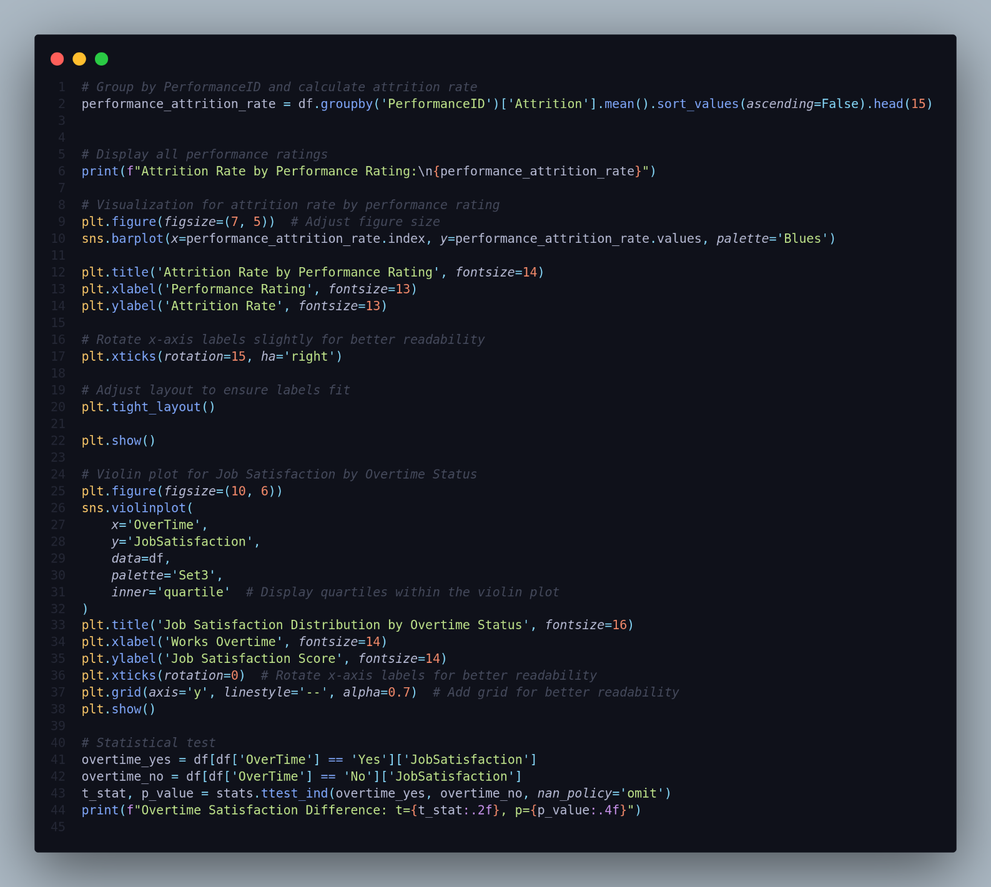

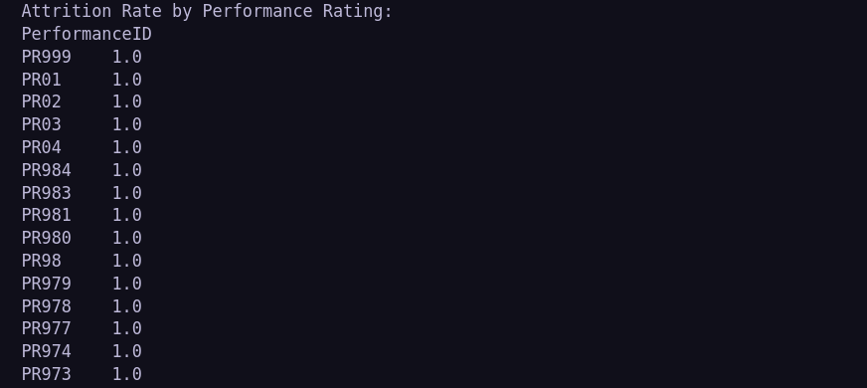

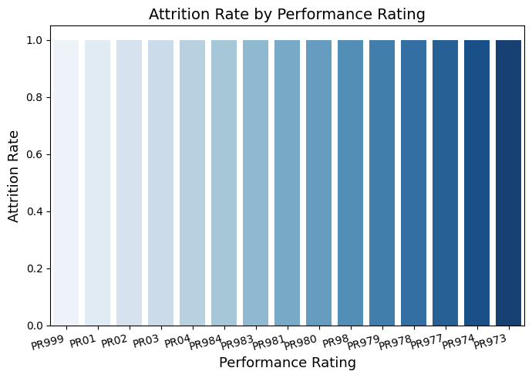

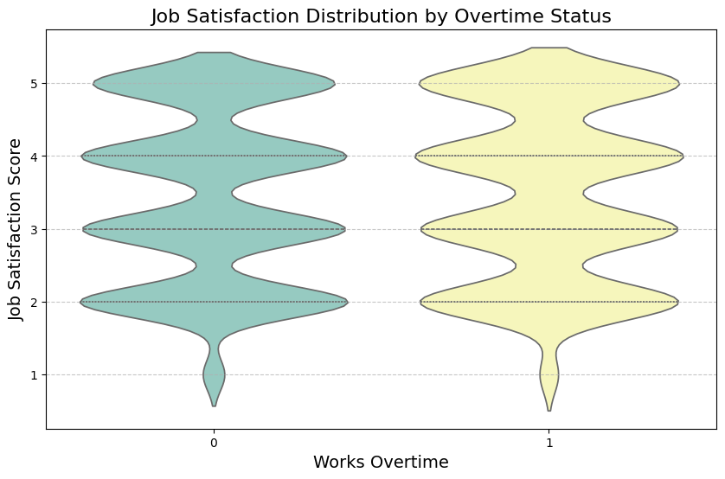

34.Is there a relationship between overtime and performance?

We analyze whether working `overtime` impacts `SelfRating` by comparing average ratings and conducting a statistical test.

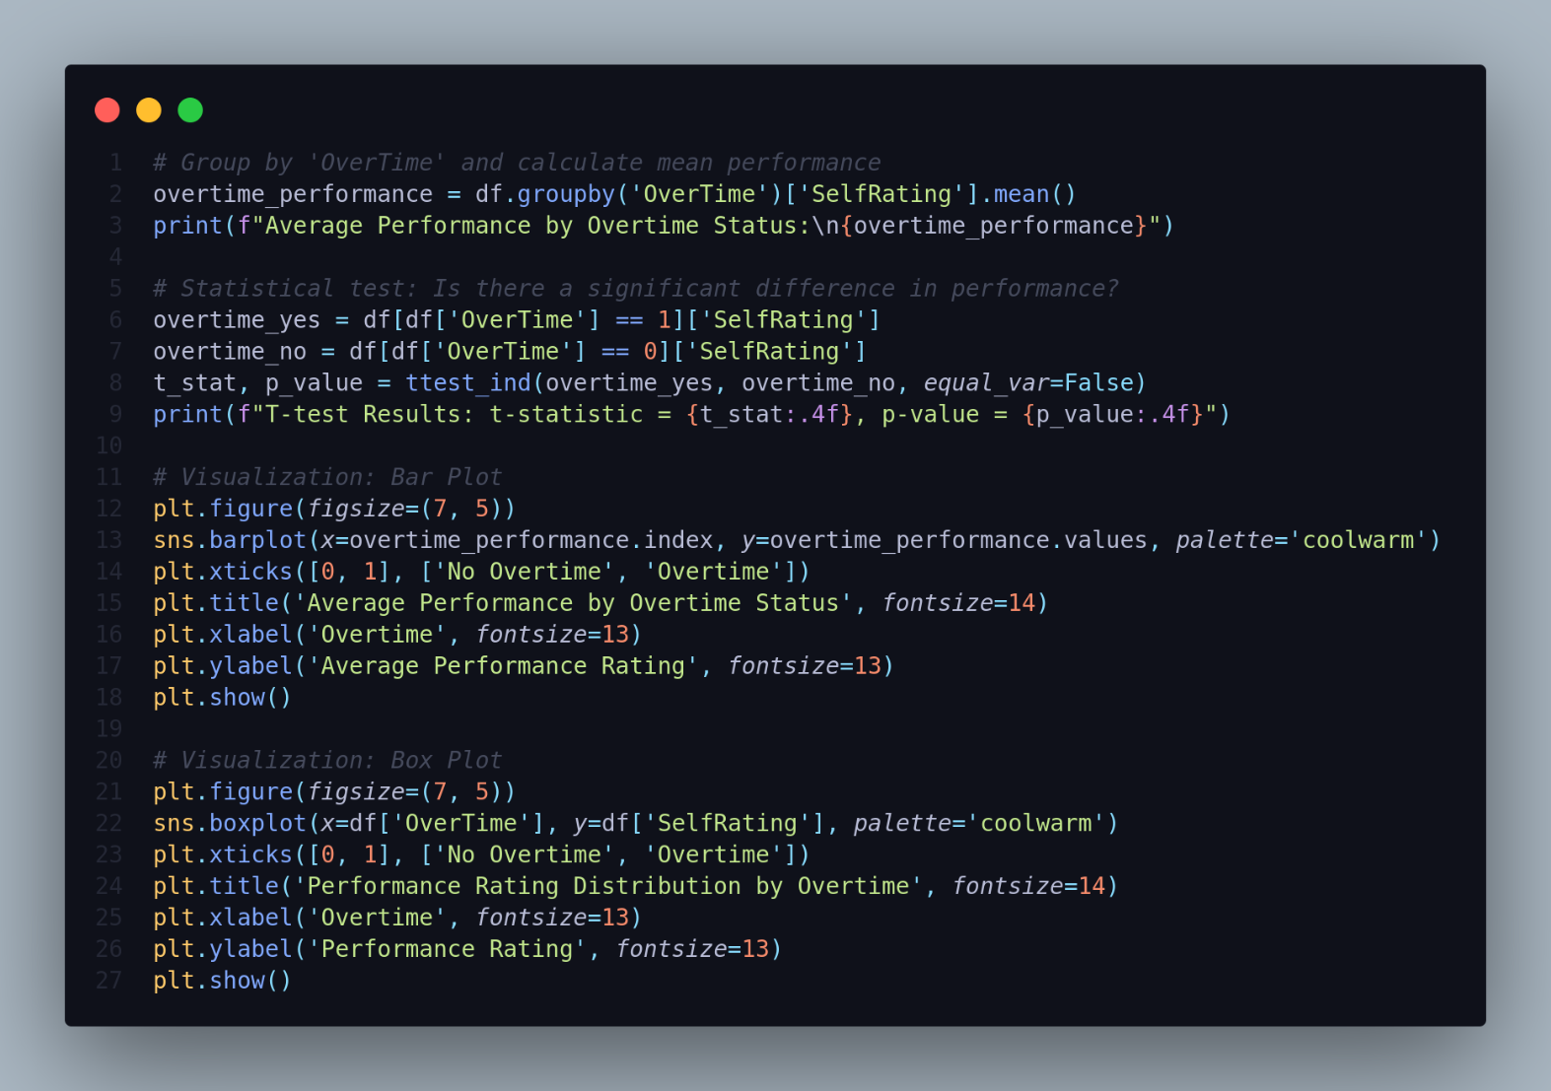

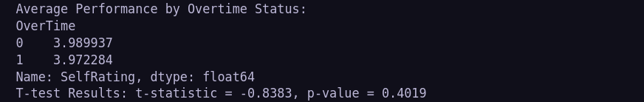

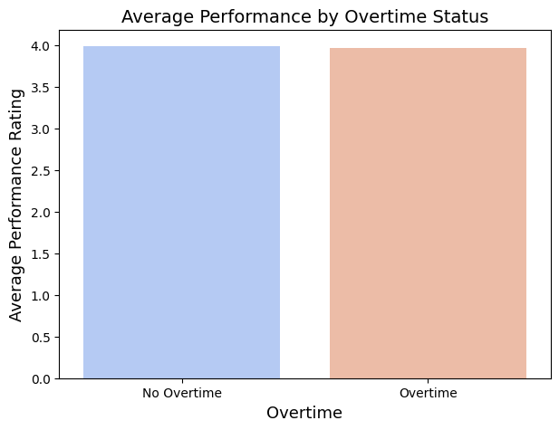

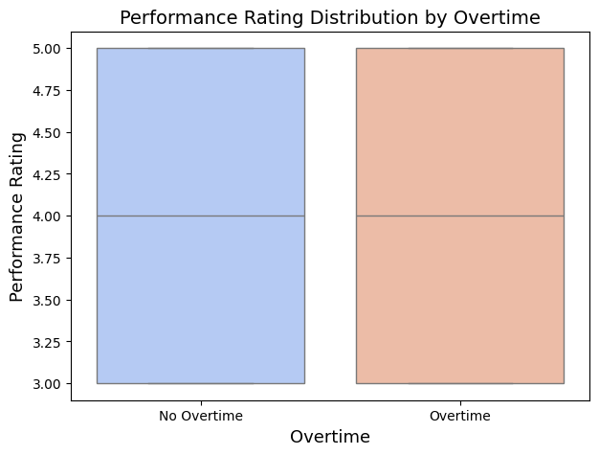

35.Can we predict the likelihood of attrition based on employee attributes?

We can create a predictive model to determine the likelihood of attrition (`Attrition`) using attributes like `YearsAtCompany`, `OverTime`, `PerformanceRating`, etc.

We'll use Logistic Regression for this predictive task.

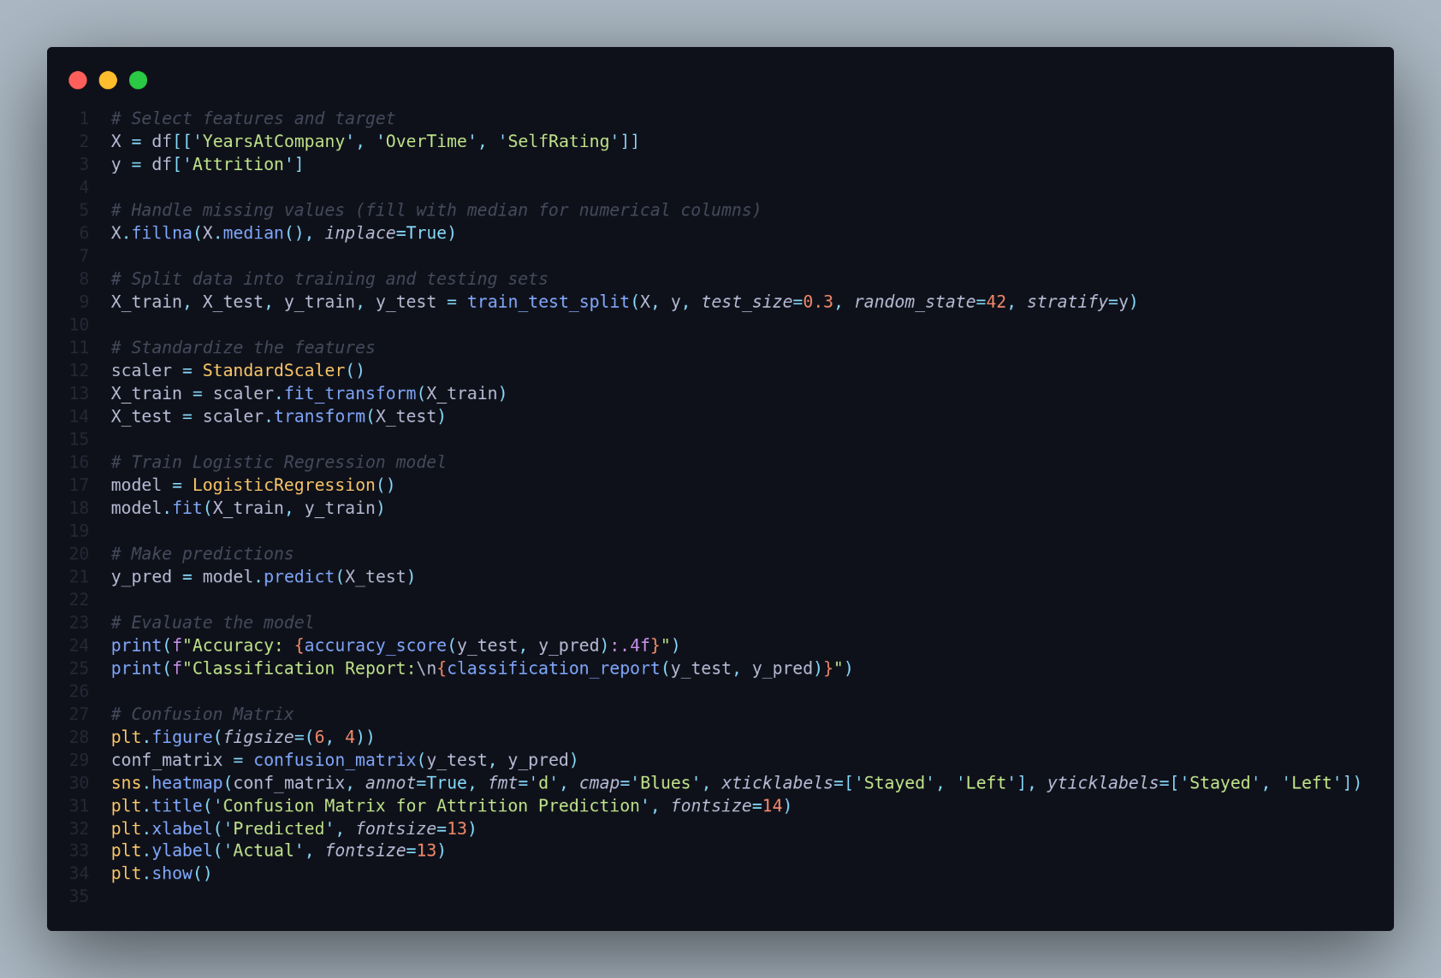

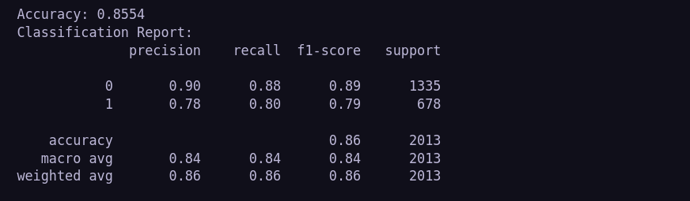

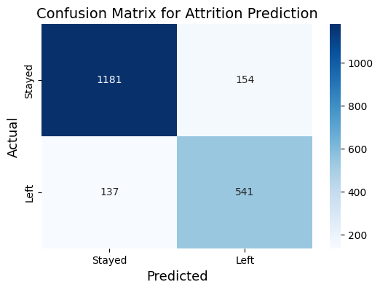

____________________________________________________

36.Are there any leading indicators of high-performing employees?

We can try to identify features that predict high performance (`PerformanceRating`).

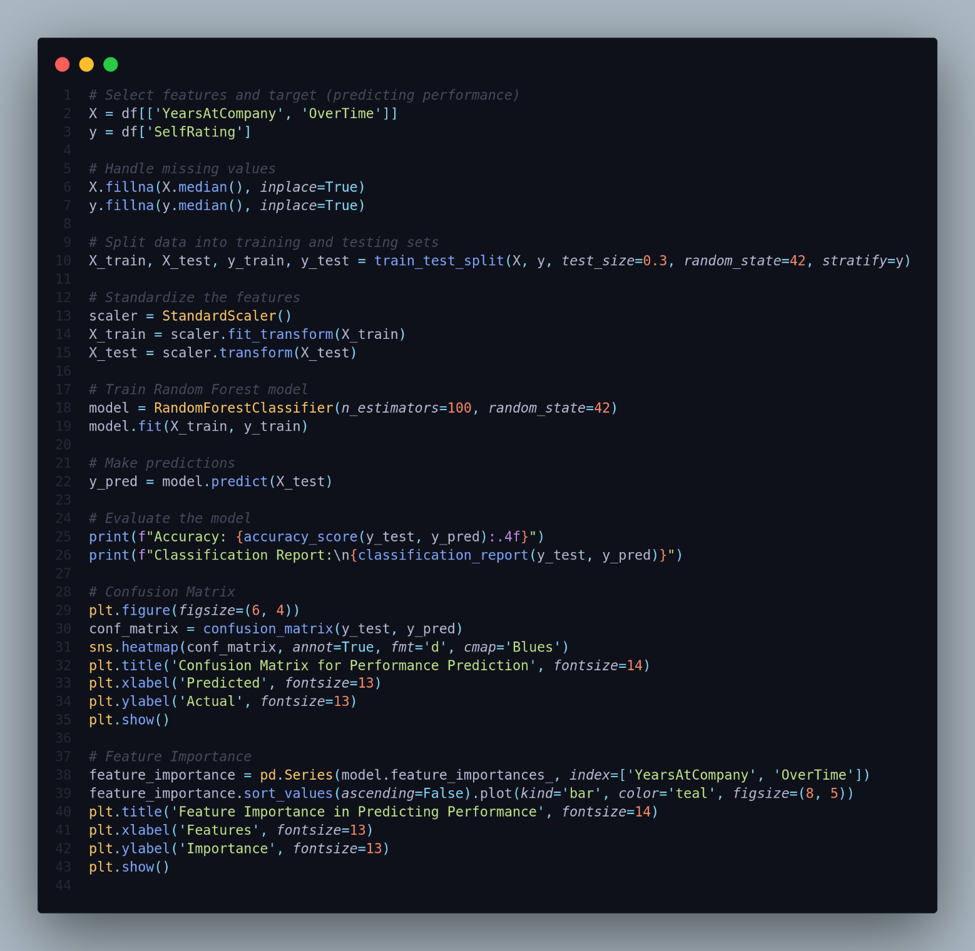

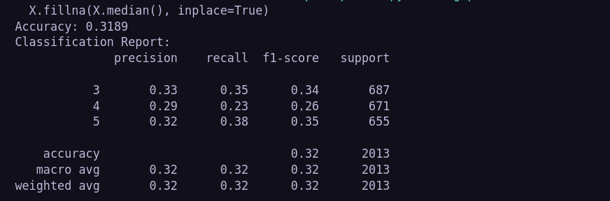

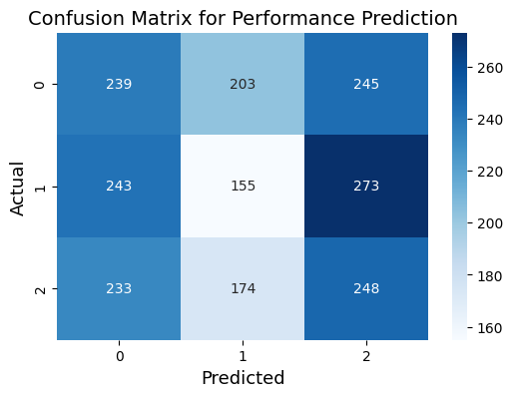

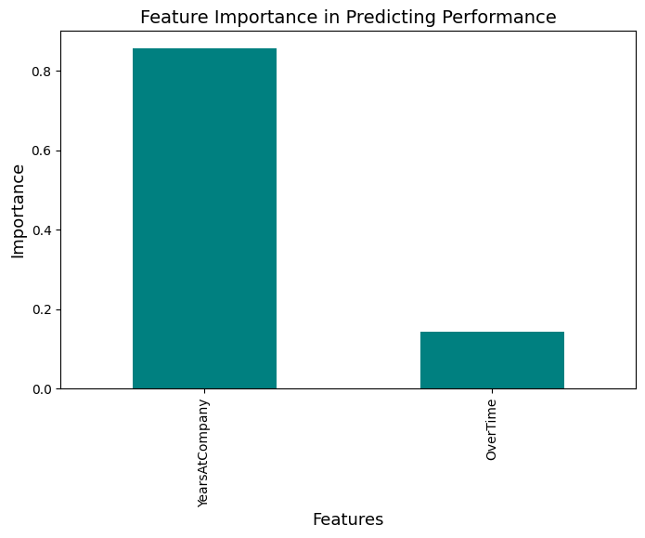

THANKES